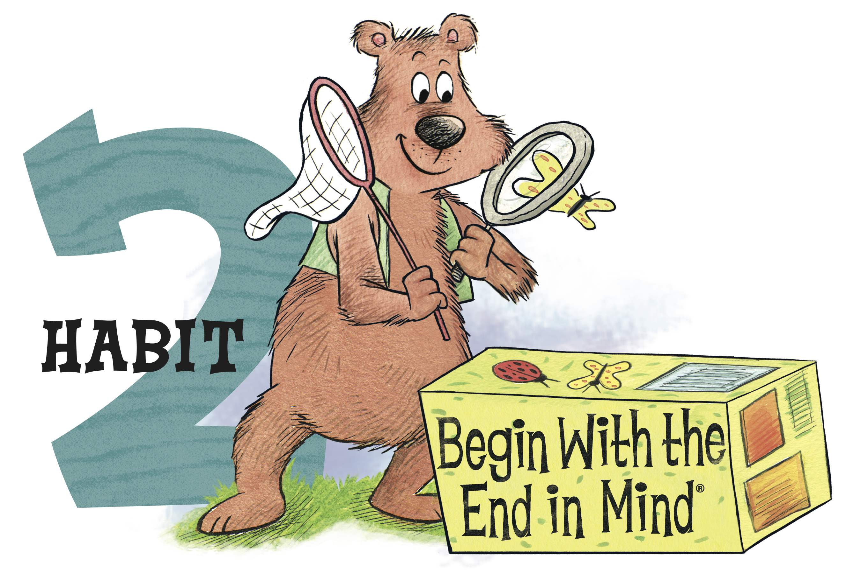

Habit 2- Begin with the End in Mind
Home Activities
Would you start a trip without knowing where you are going? Knowing what you trying to accomplish directs all the choices on the way.
Habit 2 is Begin with the End in Mind - Think about how you want something to turn out before you start it. Goal setting is an important skill for success. Set a goal. Then, break it down into small manageable pieces. A great example is a puzzle. You study the picture. Then, you sort pieces. Perhaps you’ll do the edge first. Next, you may find all the pieces of one color, and so on step- by-step until it is complete.
Ways to apply at home:
Point out examples: Share stories from your life, or even your day at work, where you had a goal or task that you accomplished. What steps did you take to accomplish it? How did breaking it down make it easier? Point out examples from your child’s life such as riding a bike, tying shoes, or another skill.
Create a goal: Is there something your child wants that he/she can work for? Better reading skills, a day with a parent, a new toy or game? Help your child set the goal and define steps they can take to achieve it. Make sure it is attainable to create a positive experience.
Look to the future: From the time they are small, adults ask kids, “What do you want to be when you grow up?” Help your child identify an interest and then encourage activities, skills, books, or other opportunities that support that interest. Show them how these little steps can lead them to greater opportunities to use this interest in a variety ways or careers in their adult life. They very well may change their mind, but they will know you support them.
Family Mission Statement: What kind of family do you want to have? What does your family value? What is your ultimate goal? Discussing it as a family and putting it in writing can help lead the whole family in a more positive direction. It can be simple: “We are kind to each other all the time so everyone will always like coming to our home.” Or it can be a paragraph. Whatever sums up your family and creates a positive picture everyone can feel a part of. Be sure to include everyone in your family in the process of creating the mission statement.
Words to use: Reminder: It is important to use a non-judgmental tone. You are inviting your child to think for themselves and share their ideas, views and conclusions with you.
“What do you plan on this being when you are finished?”
“Can we break this into more manageable steps?”
“Do you need anything from me in order for you to be successful?”
“What other steps do we need to take to reach this goal?”
“Well, what do you want more, this (immediate) or your goal of (child’s goal?)”

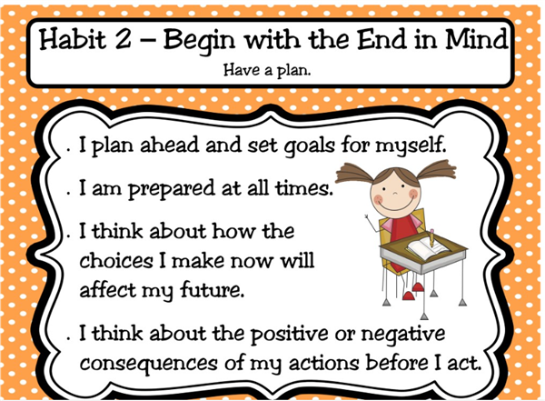

Activities courtesy: http://www.lisd.net/cms/lib010/TX01918037/Centricity/Domain/4166/Habit%202.pdf

