family dinner night!  When  Thursday 10/19  5pm – 8pm  Where  Pizza Port OB  1956 Bacon Street  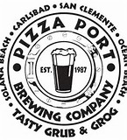 | 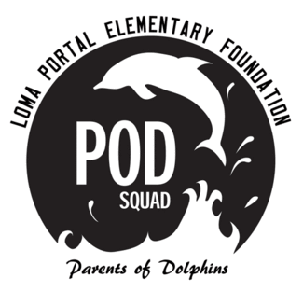  bring this flyer and pizza port will donate a percentage of sales to loma portal elementary.  you must present this flyer when ordering!  see you there!!!

