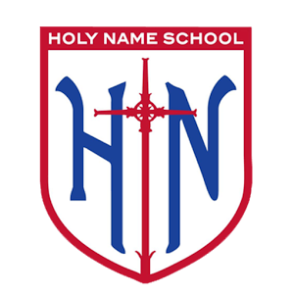

Please support the Class of 2018 to raise funds to assist in the cost of their Washington D.C. trip. Your

donation of any gently-used uniform items will be appreciated.

*Drop-off Dates: Ongoing

*Drop-off Location: Office

Please only donate uniforms in good condition

(no holes, frayed hems, missing buttons, etc…)

Sale Dates

Wednesday December 6 & Thursday December 7

Hours: Immediately after school

Wed: 3pm-3:30pm, Thurs: 2:30pm-3pm

Location: School Yard

Costs

Jumper/Skorts: $10 - $12

Sweater: $5 - $10

Polo Shirt/Pants: $2 - $10

Please contact Sandy Chau at (415-203-9873

Or [Sandy_Chau@yahoo.com)](mailto:Sandy_Chau@yahoo.com)) for more information

Holy Name

Uniform Drive