Neeraj Shah
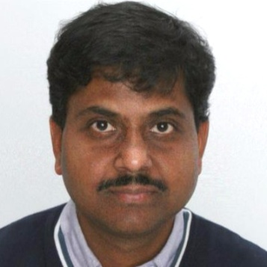
Celgene Corporation, Summit, New Jersey
Director- Clinical Supply Chain Excellence

Neeraj is responsible for clinical supply chain transformation, emerging technologies and automation of business process, developing capabilities that will help in achieving best in class supply chain processes to improves speed to clinic, minimize compliance and quality risks, improve through put and productivity.

