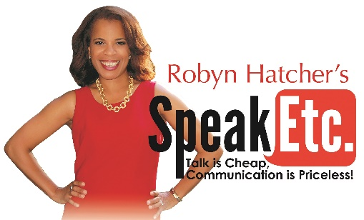

In order for me to be fully prepared for your program, please take some time to answer the following questions. The more details you give, the better I will be able to customize this program.

- Name of organization:

- Time and date of presentation:

- Composition of audience:

- Number expected to attend:

- Length of presentation:

- What is the theme of your meeting?

- What is your organization’s mission statement?

- What are your objectives for this meeting?

- What are any current concerns/problems/challenges facing your organization?

- What sensitive areas should be avoided?

- What will be taking place immediately before/after our program?

- Who has presented programs for your organization in the past, and what did the programs cover?

- Who can be contacted in case of an emergency or problem immediately prior to the event?

- What other key people will be in the audience?

- What else should I know about your organization that would make this program more meaningful?

Thank You! If you have any further questions for me, please contact me.

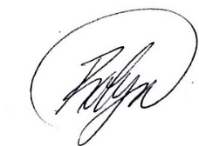

Robyn Hatcher
10 W. 15th St. #1220
New York, NY 10011
917.361.3860
Robyn@SpeakEtc.com
www.SpeakEtc.com

