Twitter Image Call to Action

Step 1 – Upload image as “Photo”
Step 2 – Tag in suggested legislators for “Who’s in this photo?” (Max of 10)
Step 2 – Add suggested Tweet (be sure to include the link to news story)
Step 4 – Hit Tweet!

Image & Tweet 1

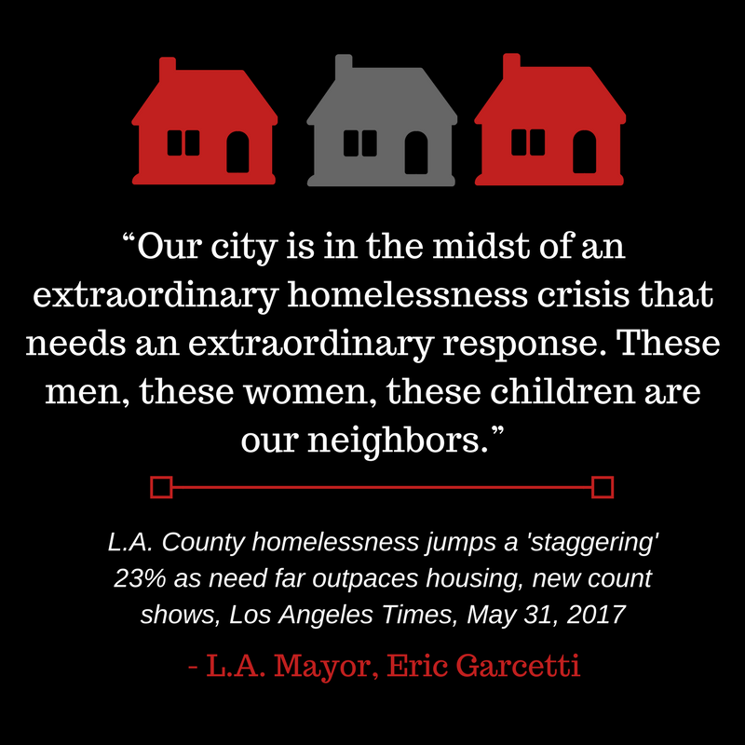

Members: @AsmRichardBloom @Rendon63rd @kdeleon @SebastianMRT @AsmAutumnBurke @JonesSawyer59 @laurafriedman43 @IanCalderon @AsmGarcia @AsmBlancaRubio

Tweet: #caleg what will it take to act on homeless & housing crises? Zero $ in #cabudget & still no action on #SB2 & #AB71
http://www.latimes.com/local/lanow/la-me-ln-homeless-count-20170530-story.html

Image & Tweet 2

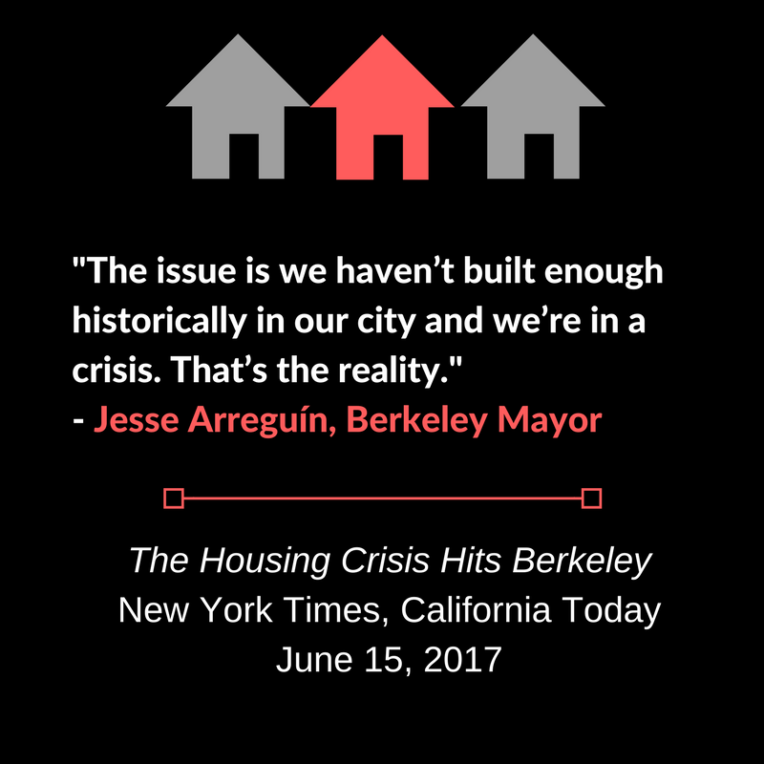

Members: @DavidChiu @PhilTing @JerryBrownGov @Rendon63rd @kdeleon @kevinmullin @Ash_Kalra ‏

Tweet: Can't solve homelessness & poverty w/out homes. Californians are looking to you #caleg for leadership. #SB2 & #AB71
https://www.nytimes.com/2017/06/15/us/california-today-the-housing-crisis-hits-berkeley.html?em_pos=large&emc=edit_ca_20170615&nl=california-today&nlid=60749306&ref=headline&te=1&_r=0

Image & Tweet 3

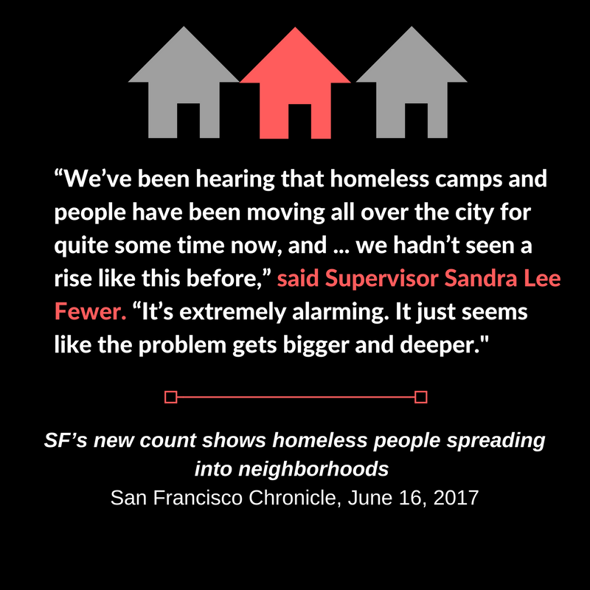

Members: @DavidChiu @PhilTing @JerryBrownGov @Rendon63rd @kdeleon @TonyThurmond @AsmGrayson @RobBonta ‏@AsmFrazier

Tweet: When will #caleg stop talking about shameful growing homeless & housing crises & ACT? California needs #SB2 & #AB71 BEFORE summer recess
http://www.sfchronicle.com/bayarea/article/SF-s-new-count-shows-homeless-people-spreading-11223996.php

Image & Tweet 4

Members: @JerryBrownGov @Rendon63rd @kdeleon @LorenaSGonzalez @AsmShirleyWeber ‏@AsmToddGloria @AsmEGarciaAD56

Tweet: Homeless ranks rise, housing crisis crushes families & seniors. How long will #caleg fail to act on #SB2 & #AB71? Housing BEFORE recess http://www.sandiegouniontribune.com/business/growth-development/sd-fi-countyhomeless-20170612-story.html

