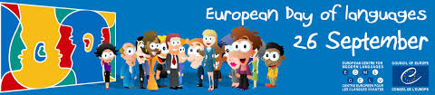

European Day of Languages
Eaquals Quiz

- What languages do Eaquals accredited members teach?
- How many of the languages taught by Eaquals accredited members are non-European languages?
- What are the three most common languages you can study at Eaquals accredited schools?
- In how many countries are Eaquals schools located?
- Which country has the highest number of Eaquals accredited schools?
- In how many Eaquals schools can you learn Chinese?
- In which Eaquals accredited school can you study the highest number of languages?
- What international examinations do Eaquals associate members offer?
- How many Eaquals accredited members took part in the summer campaign on social media this year using #eaquals18students ?

