****2nd annual trunk or treat

Cruise-In

**When:** October 30th 2016

**Where:** Sears Hardware

6169 Us Hwy 6 Portage In

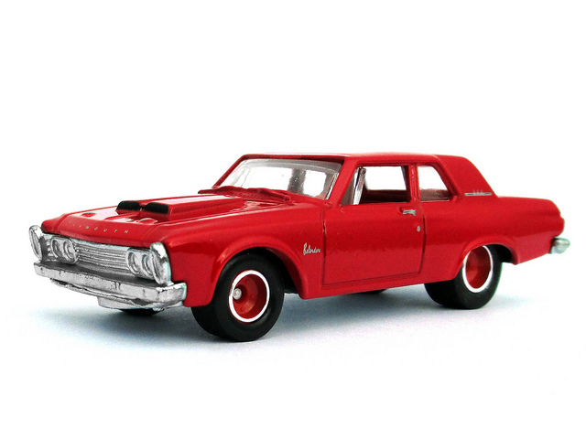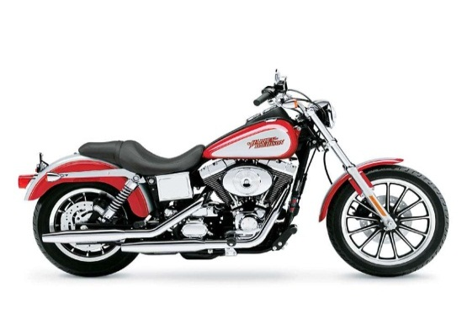(between Wal-Mart & Lowes)

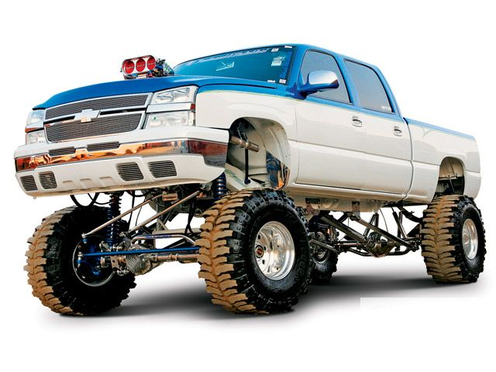*Show times are from 12-4pm*

Contact info:scott-219-545-5600