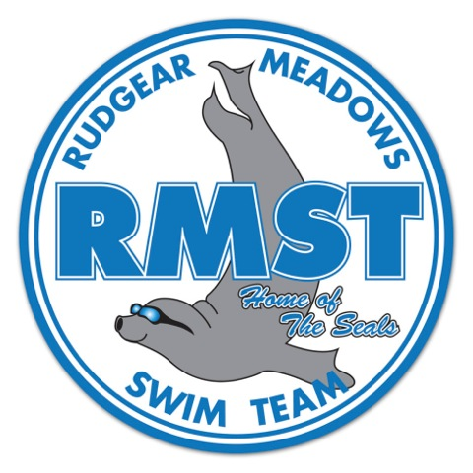

**\*Learn to swim- ages 3-6**

**\*Summer team- ages 4-18**

**(all levels welcome)**

**\*Day AND Night Practices offered**

**\*15-18’s NO swimmer fee**

**\*ALL neighborhoods/communities welcome**

**\*Low swimmer to coach ratio**

**\*OPEN HOUSE SUNDAY, MARCH 12, 3-5 PM**

Registration opens February 1

[www.rmstseals.org](http://www.rmstseals.org)

**Questions? Email us at:**

[membership@rmstseals.org](mailto:membership@rmstseals.org)

***Building Tradition One Stroke at a Time***

**Rudgear Meadows Swim Team-Building Tradition One Stroke at a Time**