Leech Lake Association
MEMBER OF THE WEEK
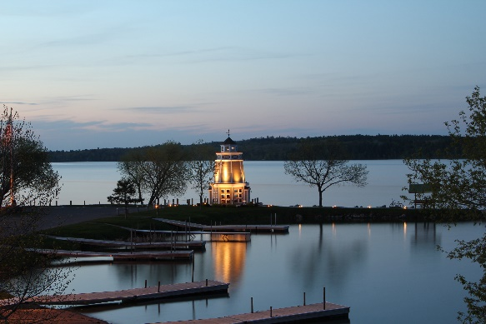

The Leech Lake Association is a non-profit organization dedicated to preserving good fishing and the relatively pristine nature of Leech Lake for future generations. Originally founded in 1970, the Association is governed by a 12-member Board of Directors who represent the interests of its large membership, which numbers some 400 homes and businesses around the lake -- all united in common cause to protect the lake's water quality, fishery, shorelands and spawning beds, and -- most recently -- to keep zebra mussels and other Invasive Species out of the lake. The group's reason for being can be summed up as follows: " To be good stewards of Leech Lake and its environs, recognizing the vulnerability of the lake, and the need for citizens -- both individually and collectively -- to assume responsibility for its care."
Some recent or current projects of the Leech Lake Association include participation on the Leech Lake Fishing Advisory Committee which developed the 2015-2020 five-year plan to maintain great fishing in Leech Lake, plus serving on boards of the Association of Cass County Lakes and the Leech Lake Area Watershed Foundation to bring maximum influence and resources to bear on issues/ threats affecting Leech Lake. The Association also works with the Tribe and Cass County Sheriff on keeping the Roosevelt Canal navigable to boaters through periodic dredging, volunteering with the DNR during annual test netting operations, and assisting with boat inspections and weigh-ins during the Leech Lake Fishing Tournament. We also successfully lobbied the DNR for the new fishing pier on Shingobee Island.
If you would like to get involved or learn more about any of our projects, we invite you to attend one of our meetings which are held on the third Monday of each month at 9:30 AM at the Cass County Courthouse. Or contact us on through our website at:
http://www.leechlakeassociation.com/mission.html
The Leech Lake Area Chamber of Commerce presents Leech Lake Association as the Member of The Week! Each week a new business will be featured as a “thank you” for being a part of our membership. If you are interested in becoming a member of the Leech Lake Area Chamber of Commerce please give us a call at 218-547-1313 and we will be happy to give you some more information!

