Georgia Association of Community Services Boards
21st Annual Spring Fling
April 29 - May 2, 2018
Epworth by the Sea
Saint Simons Island, GA

Sunday, April 29, 2018

4:00 p.m. - 6:00 p.m. Check In & Conference Registration Front Desk/Lobby

5:30 p.m. - 7:00 p.m. Dinner Smith Dining Hall

7:00 p.m. - 7:15 p.m. Welcome Strickland Auditorium

Robyn Garrett
Executive Director
Georgia Association of Community Service Boards
Douglasville, GA

7:15 p.m. - 7:45 p.m. Keynote Address Strickland Auditorium

Honorable Stephen Kelley
Glynn County Superior Court
Brunswick, GA

7:45 p.m. – 9:00 p.m. Talent Show Strickland Auditorium

MC’d by: Melvin Harris
Emory Pitts
Monday, April 30, 2018

7:00 a.m. - 8:30 a.m. Breakfast Smith Dining Hall

8:45 a.m. - 9:00 a.m. Welcome & Opening Remarks Strickland Auditorium

Robyn Garrett
Executive Director
Georgia Association of Community Service Boards
Douglasville, GA

9:00 a.m. - 9:30 a.m. Recovery on Fire Strickland Auditorium
Bill Carruthers CPRP-CPS-MH-AD-WH CARES
Peer Workforce Development & Training Director
Highland Rivers Health
Cartersville, GA

9:45 a.m. – 10:45 a.m. Georgia Peer Recovery Certifications Panel/ Clary I
Employment Opportunities

Sheila Corn
Outreach Coordinator
RESPECT Institute of Georgia
Georgia Mental Health Consumer Network
Decatur, GA

Roslind Hayes, CP, CARES, WH-WC
Statewide Coordinator
Peer Support, Wellness, and Respite Centers
Georgia Mental Health Consumer Network
Decatur, GA

Karen Daniels, CARES
CARES Liaison
Certified Addiction Recovery & Empowerment Specialist
Georgia Council on Substance Abuse
Atlanta, GA

9:45 a.m. – 10:45 a.m. Employment Express/ Strickland Auditorium Employment Opportunities for Individuals Living with an Intellectual/Developmental Disability
Charles Hopkins, Consultant
Georgia Department of Behavioral Health and Developmental Disabilities
Atlanta, GA
Monday, April 30, 2018

10:45 a.m. - 11:00 a.m. Break/Snack ½ Strickland Auditorium & ½ Clary I

11:00 a.m. - 12:00 noon CARES/CPS/Respect Institute Peer Panel Clary I

Graden Thompson
Unison BH (MH Court)
Waycross, GA

& Other Guest Speakers

Intellectual/Developmental Disabilities Strickland Auditorium
Peer Panel

Guest Speakers

Wellness Activities
Yoga by Cathy Parker Pioneer at Turner Lodge
Art for Wellness by Sam Rapier Jones Craft

12:00 noon - 1:30 p.m. Lunch Smith Dining Hall

1:45 p.m. - 2:45 p.m. Medication Wellness Strickland Auditorium
Lisa Moxley Lassiter, RPh
Director of Clinical Services
Guardian of South Georgia
Statesboro Ga

2:45 p.m. - 3:15 p.m. Break/Snacks Strickland Auditorium
Monday, April 30, 2018

3:15 p.m. - 4:15 p.m. Legislative Affairs & Self Advocacy Strickland Auditorium

Don Hogan
State Representative
St. Simons Island, GA

Travis Lindley
Capitol Strategy Group
Atlanta, GA

Wellness Activities

Yoga-By Cathy Parker Pioneer at Turner Lodge
Art for Wellness-By Sam Rapier Jones Craft

4:15 p.m.-4:45 p.m. Prepare for Beach Outing Massengale Park

5:00 p.m. – 9:00 p.m. Fitness, Fun, & Food Beach

Surf N Turf Activities on the Beach & In the Ocean
Grillin’ Party In The Park
Sponsored by Glyn County Volunteer Fire Department

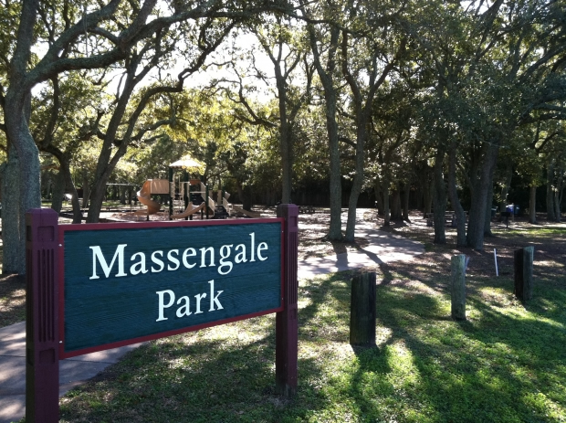
Tuesday, May 1, 2018
7:00 a.m. - 8:30 a.m. Breakfast Smith Dining Hall

8:30 a.m. - 9:30 a.m. Leaders in Recovery Clary I

David Kidd, CARES
President
Georgia Association of Community Service Boards

Enhancing Dreams of Independence Strickland Auditorium

Ron Wakefield
Division Director for Developmental Disabilities
Georgia Department of Behavioral Health and Developmental Disabilities
Atlanta, GA

9:45 a.m. – 10:45 a.m. W.H.A.M. for Women (Part 1) Strickland Auditorium
Whole Health Action Management

Roslind Hayes, CPS, CARES, WH-WC
Statewide Coordinator
Peer Support, Wellness, and Respite Centers
Georgia Mental Health Consumer Network
Decatur, GA

W.H.A.M. for Men (Part 1) Clary I
Whole Health Action Management

Bill Carruthers CPRP-CPS-MH-AD-WH CARES
Peer Workforce Development & Training Director
Highland Rivers Health
Cartersville, GA

Melvin Harris
Consumer Affairs Director
River Edge Behavioral Health
Macon, GA

Emory Pitts
Consultant
Macon, GA

10:45 a.m.-11:00 a.m. Break/Snacks Strickland Auditorium

Tuesday, May 1, 2018
11:00 a.m. – 12:00 noon Crisis Intervention Teams (CIT) Strickland Auditorium

Pat Strode
Advocate Coordinator
Crisis Intervention Team
Georgia Public Safety Training Center
Forsyth, GA

Wellness Activities

Yoga by Cathy Parker Pioneer at Turner Lodge
Art for Wellness by Sam Rapier Jones Craft

12:00 noon – 1:30 p.m. Lunch Smith Dining Hall

1:30 p.m. – 2:30 p.m. W.H.A.M. for Women (Part 2) Strickland Auditorium
Whole Health Action Management

Roslind Hayes, CPS, CARES, WH-WC
Statewide Coordinator
Peer Support, Wellness, and Respite Centers
Georgia Mental Health Consumer Network
Decatur, GA

W.H.A.M. for Men (Part 2) Clary I
Whole Health Action Management

Bill Carruthers CPRP-CPS-MH-AD-WH CARES
Peer Workforce Development & Training Director
Highland Rivers Health
Cartersville, GA

Melvin Harris
Consumer Affairs Director
River Edge Behavioral Health
Macon, GA

Emory Pitts
Consultant
Macon, GA

2:30 p.m. – 3:00 p.m. Break/Snacks Strickland Auditorium

3:00 p.m. – 4:00 p.m. Open Mic Session Strickland Auditorium
Stories of Independence & Recovery

Tuesday, May 1, 2018
4:15 p.m.-7:00 p.m. Wellness Activities

Yoga by Cathy Parker (4:15pm-5:15pm) Pioneer at Turner Lodge
Fishing For Fun with First Responders Epworth Piers
Art for Wellness by Sam Rapier (4:15pm-6:15pm) Jones Craft

5:30 p.m.-7:00 p.m. Dinner Smith Dining Hall

7:30 p.m-10:00 p.m. Groovin’ to the Music Dance Jones Auditorium

Wednesday, May 2, 2018

7:00 a.m. - 8:30 a.m. Breakfast Smith Dining Hall

8:30 a.m. - 9:30 a.m. Disability Act Rights/ Strickland Auditorium
Social Security

Rachael Henderson
Attorney at Law
Georgia Legal Services Program
Brunswick, GA

Wellness Activities

Yoga by Cathy Parker Pioneer at Turner Lodge
Art for Wellness by Sam Rapier Jones Craft

9:30 a.m. - 9:45 a.m. Break

9:45 a.m. - 10:45 a.m. Recovery Empowerment Council Strickland Auditorium
May Meeting

Bill Carruthers CPRP-CPS-MH-AD-WH CARES
Peer Workforce Development & Training Director
Highland Rivers Health
Cartersville, GA

10:45 a.m. - 11:15 a.m. Return Keys Epworth Front Desk

11:15 a.m. - 12:00p.m. Closing Remarks Strickland Auditorium
Certificate of Attendance
Wednesday, May 2, 2018

12:00 noon-1:30 p.m. Lunch Smith Dining Hall

SAFE TRAVELS HOME!
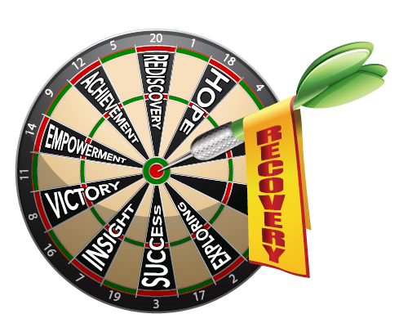
If you need help, please locate one of the following hosts:
- Judith Masching, RN
- Dr. Kay Brooks, Aspire BH/DD
- Bill Carruthers, Highland Rivers Health
- June DiPolito, Pineland CSB
- Lesley White, Unison BH
- Melvin Harris, River Edge CSB
- Emory Pitts, Macon, GA
- Robyn Garrett, GACSB
- John Powell, GACSB
- Lyly Trinh, GACSB

MEDICAL NEEDS
- FIRST find your staff person.
- Then have your staff person contact the nurse if needed:
Judy Masching, RN
*Staff: See back of your name badge for her cell*
If you are unable to contact her, call Lyly Trinh at 912-704-1729 or John Powell at 912-704-6290.

Objectives:
- To educate attendees on the following:
- Living well through a whole-health approach
- Certification for Certified Peer Specialists
- Certification for Certified Addiction Recovery Empowerment Specialists
- Getting involved with The Respect Institute
- Supported Employment opportunities with Employment Express program
- Living independently
- Georgia’s legislative affairs processes
- Self-Advocacy
- Empowerment through personal journeys
- Georgia’s CIT Program
- Disability Rights Act
- Social Security benefits
- Health and Wellness activities with yoga sessions and art
- Medication wellness
- Socialization skills and networking
- Fellowship

Please Read Carefully:
- Prevent the spread of infection: WASH YOUR HANDS AFTER USING THE BATHROOM, SMOKING, AND BEFORE/AFTER EATING.
- Please be aware of your bathroom etiquette and behavior.
- No smoking inside any bathroom or bedrooms on the campus.
  - Smoking is only permitted in designated areas outside of buildings. Please be sure to put your butts in designated receptacles at all times.
- Please do not over fill your plates at meal/snack times nor hoard food.
- Participants are asked to please be courteous to the presenters by refraining from taking phone calls, sleeping, talking, or moving about during the sessions.
- Staff are not to leave the campus or leave their individuals unattended. Please stay with or know where your attendees are in the event an emergency should happen.

