FYI 55+ Goes to Tennessee Amish
March 19 to 21, 2018 Hamilton Mill United Methodist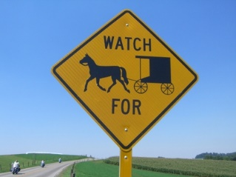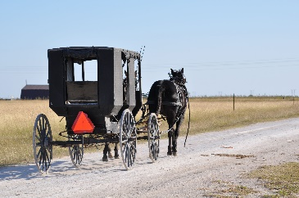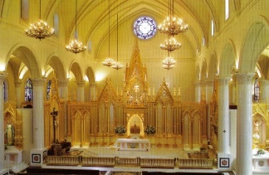

Monday, March 19, 2018 Departing HMUMC, with Pastor Jason, at 8:00 AM, we will be ready for an inspirational visit to Ivy Green, the childhood home of Helen Keller. The little cottage is where her teacher, the Miracle Worker, taught her to communicate in her world of darkness and silence. Stopping on our way, we will have a self-hosted lunch and later an included dinner. Our overnight hotel is the Comfort INN and Suites in Pulaski, Tennessee for two nights.
Tuesday, March 20 After an included breakfast at our hotel, we will depart at 8:15 for a tour of the Amish countryside with a guide in Ethridge, Tennessee. These are old order Amish and we will learn why they chose to settle in this part of Tennessee. There will be places to shop at their homes for jams, baskets, quilts and furniture. We will have an included lunch.
After lunch we have a great surprise. This is a Civil War town, of Franklin, Tennessee, that is charming and historic. Our local guide will give a great tour. You will not be disappointed. Dinner on your own in this famous town.
Wednesday, March 21 Please bring your suitcase down to the bus at 7:00 am and then have a wonderful included breakfast. We depart at 7:30 for Cullman, Alabama to hear the stories of the nuns and the answers to the prayers to build this beautiful cathedral. Shrine of the Most Blessed. We will stop for a self -hosted lunch and other breaks on the way home.
Included in our trip:
- Transportation
- Two nights hotel
- Two breakfasts
- One lunch
- One dinner
- Helen Keller’s Home tour
- Amish tour
- Civil War town tour
- Cathedral tour
- Travel Insurance
- Snacks and water on the bus
- Letter and luggage tags about two weeks before we leave with reminders
Not included is a couple of meals and gratuities for all our step on Guides.
For any questions, please call 770-965-7774 Barbara Goss
Registration form and deposit is due by Feb. 1, 2018 $100 per person.
Final payment of $232.00 double and $288.00 for a single is due by March 1
Total trip cost $332.00 for a double and $388.00 for a single.
Please make your checks out to HMUMC and on the check line put AMISH.

