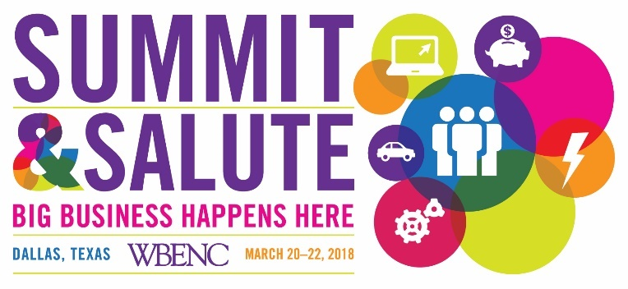

2018 Summit & Salute FACT Sheet

2018 Summit & Salute: Big Business Happens Here
The 2018 Summit & Salute brings together America’s leading corporations, government agencies, women business owners and their staff, and strategic partner organizations. At this year’s exciting event we will explore the big business opportunities in Dallas, TX and in the WBENC Network! Summit & Salute engages participants in a two-day program filled with captivating keynotes, business development opportunities, future forward themed workshops and informal networking engagements.
WBENC is excited to bring the 20th Summit & Salute back to where the organization was founded in Dallas, TX home of the Women’s Business Council-Southwest region. We will honor our 2018 Women’s Business Enterprise Stars and pay tribute to the 2017 America's Top Corporations for Women's Business Enterprises.

Presenting Sponsors:

Accenture Ampcus Inc.

Bristol-Myers Squibb ASAP Solutions, LLC

EY

Highlight Event: The Procurement Opportunity Connection
(WBENC-Certified WBEs Must Register by January 22, 2018 to qualify for the 1:1 Matchmaker Meetings)
Participating Corporate Members will be available in two separate sessions:
- A Meet & Greet round table session designed for WBENC-Certified WBEs to introduce their company’s products and/or services to participating Corporate Members. No appointments are required.
- 1:1 MatchMaker Meetings for WBENC-Certified WBEs to meet* with Corporate buyers and their prime suppliers/key business partners to explore 1st, 2nd, and 3rd tier sourcing prospects and to learn how to be considered.
*Appointments for meetings with Corporate Members and their prime suppliers will be scheduled based on the corporation’s interest and applicability and are not guaranteed.

Who can attend Summit & Salute? EVERYONE— WBENC invites all WBENC-Certified Women Business Enterprises (WBEs), WBENC Corporate and Government Members – including senior level executives, Regional Partner Organizations (RPOs), buyers and procurement representatives, supplier diversity professionals, and federal, state, and local government officials. We also invite non-WBENC-Certified business owners and non-WBENC member Corporate and Government representatives to join us and learn about our organization and vast community.

When and where will WBENC’s 2018 Summit & Salute be held? WBENC’s 2018 Summit & Salute will be held March 20-22nd at the Hilton Anatole in Dallas, TX. The Salute! Dinner will take place on Thursday night March 22, 2018.

How do I register? Go to http://summit.wbenc.org to register today and reserve your hotel room at the WBENC group rate. Early bird pricing ends January 22, 2018. See the available Sponsorship opportunities through the Summit & Salute registration site or in the 2018 WBENC Sponsorship Brochure. Opportunities are going fast, so get your preferred package now!

Who do I contact for additional information?
For online registration questions call Customer Service toll free at 1-800-310-7554, 9am-5pm, EST, Monday – Friday or send an email to:
Attendees – WBENCSummitattendees@experient-inc.com
Sponsors – WBENCSummitsponsors@experient-inc.com
International registrants, please call 240-439-2554
For general registration questions contact WBENC Customer Service at wbenccustsvc@wbenc.org
For sponsorships, contact Mia Delano, at valuedsponsors@wbenc.org or 202.315.1501
For press inquiries email press@wbenc.org

