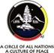

August 9 is the United Nations International Day of the World’s Indigenous Peoples
A Circle of All Nations Blog by Romola V. Thumbadoo – August 2016

Indigenous voices have been a difficult challenge for the world, and in particular the colonized world, and over recent centuries they have been rendered almost voiceless and invisible in their own ancestral lands, by colonizers, early settlers and new immigrants; certainly this has been the case in my home of the past forty five years: Canada. Yet far from being a fading voice, this tiny percentage of the world’s population is resounding on our national stage – and many of us now look with a strange mix of shame, guilt, compassion, awe, and growing interest in the First Peoples of our various homelands.

According to United Nations reports, Indigenous peoples are recognized as being among the world’s most vulnerable, disadvantaged and marginalized peoples. Spread across the world from the Artic to the South Pacific, they number, at a rough estimate, more than 370 million, in some 90 countries. While they constitute approximately five per cent of the world’s population, indigenous peoples make up 15 per cent of the world’s poor and one-third of the world’s extremely poor.

The United Nations Declaration on the Rights of Indigenous Peoples (UNDRIP) was passed on September 13, 2007 by an overwhelming majority of the United Nations General Assembly. One hundred and forty-four member States voted in favor of the UNDRIP, eleven abstained, and four (Australia, Canada, New Zealand, and the United States) voted against it. Since 2007, all four countries, including the United States, have reversed their positions and now officially endorse it. The UNDRIP ensures that Indigenous Peoples' rights to cultural integrity, education, health, and political participation are protected. The UNDRIP provides for the recognition of Indigenous Peoples' rights to their lands and natural resources, and the observation of their treaty rights. The Declaration also requires countries to consult with indigenous peoples with the goal of obtaining their consent on matters that concern them.

The United Nations Educational, Scientific and Cultural Organization (UNESCO) is engaged in Indigenous issues pertaining to human rights, discrimination, gender equality, poverty eradication, democracy, sciences and social transformations, including urbanization and migration.

Launched on August 9, this year’s International Day of the World’s Indigenous Peoples message is focused on the right to education: “Indigenous peoples have the right to establish and control their educational systems and institutions providing education in their own languages, in a manner appropriate to their cultural methods of teaching and learning.”
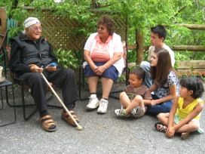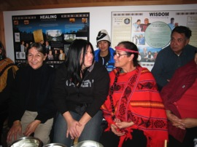

In an increasingly globalized and diversified world, Indigenous Peoples emanate an presence both ancient and contemporary – contemporary in the sense they the offer new ideas and insights into dilemmas that now besiege the human family – climate change and multiple environmental challenges, peace building and racial harmony, oppression, inequality, social justice, physical, mental and spiritual well being; ancient in that they are a constant reminded of our collective connection to the penultimate provider and nurturer, Mother Earth. In this, Indigenous Peoples remind us about relationship – relationship with land and water, with plants and animals, with each other; the fact that we are interconnected with all of life is ingrained in the Algonquin word, Ginawaydaganuc, We are all related.

It was a word that was constantly on the lips of late Indigenous Elder William Commanda, founder of the Circle of All Nations, an informal, unfunded, global eco-community dedicated to Indigenous wisdom, respect of Mother Earth, racial harmony and peace building, and social justice. Many now recognize him as a remarkable Indigenous voice for reconciliation.

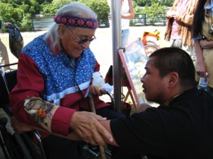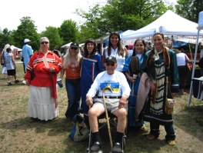

Reconciliation is critical on multiple levels. Increasingly, developed countries are paying attention to the plight of people in third world countries – however, we don’t often realize that third world conditions exist for many Indigenous peoples in homelands in the developed world. Indigenous Peoples face challenges at every turn: poverty, education, health care, employment, housing, systemic and overt racism, physical, mental and sexual abuse; they are overrepresented in the criminal justice system; and crises are mounting with unsolved murders, suicides and substance abuse.

Yet Indigenous People are remarkably resilient, and are claiming their rightful place on the global stage; further, they have much to offer workers and learners in the social services. Indigenous restorative practices such as talking, healing and sentencing circles, can strengthen an increasing dehumanized criminal justice system – family group conferencing, a restorative justice intervention, is a traditional conflict resolution practice of Maori Peoples of New Zealand; a young autistic American Circle of All Nations colleague created a documentary, Inner Healing: Indigenous Trees of Wisdom, seeking help from Indigenous healers while on his own personal development journey; the strategies to deal with meltdowns and frustrations that he explores are pertinent to a range of disciplines addressing mental wellness challenges.

Indigenous Circle of Courage principles, conceptualized in the form of a Medicine Wheel grounded on the ideas of belonging, mastery, independence and generosity, inform multiple aspects of the Isibindi Safe Parks Child and Youth Care Work of the National Association of Child Care Workers (NACCW). Elder Commanda hosted NACCW youth at his International Millennium Peace Gathering in Canada, and supported an early Isibindi training workshop in South Africa. Circle of All Nations has explored the value of traditional Indigenous approaches to child care, racial harmony and justice issues, offering workshops in South Africa and Canada, in order to facilitate reclamation, increasingly mindful that these strategies might not only be tremendously helpful to Indigenous peoples, but also to others.

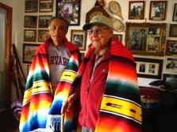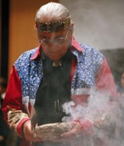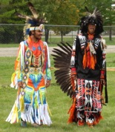

Many now realize that it is critically important and mutually beneficial for meaningful bridges to be built with Indigenous Peoples; education at multiple levels can contribute to such a process. Our passion and commitment with Dr. William Commanda’s Circle of All Nations work is to facilitate such linkages and co-creation of pathways into a collective global future, consistent with he fifty years of outreach and leadership.

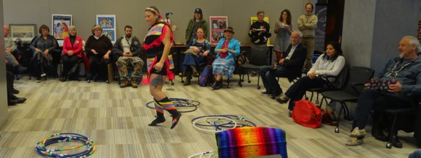

Here are a few links you may be interested in checking out:

http://www.ohchr.org/Documents/Issues/IPeoples/UNDRIPManualForNHRIs.pdf

http://www.unesco.org/new/en/indigenous-peoples/social-inclusion-and-social-change/undrip-shs/

www.circleofallnations.ca Note for example this report: CAN Child and Youth Care Worker Workshop Report

Adrian Esposito’s Inner Healing Documentary is available at Amazon.com and www.espocinema.com

www.asinabka.com

Don’t hesitate to contact us for further information or links at circleofallnations@sympatico.ca

…bridging…

