Circle of All Nations
January 28, 2017
Learning From a Kindergarten Dropout Book Discussion at Singing Pebble Book Store

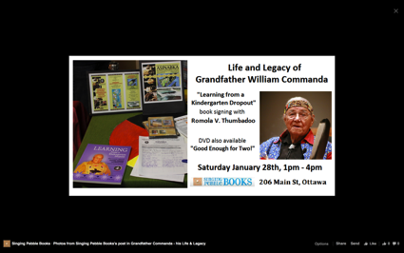

Join us for informal discussion about the work and legacy of the late Algonquin Elder, William Commanda, as presented in the book "Learning from a Kindergarten Dropout" written by Romola V. Thumbadoo in consultation with Grandfather Commanda.
William Commanda was a highly respected and loved spiritual leader of the Algonquin Nation of the Ottawa River Watershed. He worked tirelessly to raise attention to Indigenous rights and wisdom, environmental stewardship, and multiple social justice issues, and developed the vision for the Asinabka Indigenous Peace Building Centre at the Sacred Chaudiere Falls Site just upstream from Parliament. He founded the Circle of All Nations, an unfunded, informal global eco-peace community, and organized its first gathering fifty years ago in Eganville Ontario, in a gesture of reconciliation across North America - these gatherings became an annual tradition drawing thousands to his lake-side property in Kitigan Zibi every August long weekend.
Earlier in his life, Grandfather Commanda served as chief of the Kitigan Zibi Anishinabeg; he was also Supreme Chief of the North American Indian Nations Government, the precursor to the Native Indian Brotherhood/Assembly of First Nations. He was carrier of three Wampum Belts of sacred and historical importance. He was a birch bark canoe maker and craftsman of world renown - Valerie Pouyanne's canoe documentary "Good Enough for Two!", which explores craft and philosophy, will also be available for review and purchase at this event.
Over the course of his lifetime, Grandfather Commanda received many honours, including two honorary doctorate degrees, the Key to the City of Ottawa, and appointment as Officer of the Order of Canada.
THE BOOK:
"Learning From A Kindergarten Dropout" is a 192 page full-colour journal / mini-history on William Commanda and his peoples along with an overview of many key Indigenous concepts pertaining to the medicine wheel, law of nature, Aboriginal justice, child raising, forgiveness and healing. It shares stories about special people whose paths intersected with his, and includes many photos and illustrative/conceptual graphics and easily adapted teaching and training tools and is a rich resource for Aboriginal and non-Aboriginal readers, teachers and students. Its a great gift idea for conferences too! The book illustrates deep respect for Mother Earth, promoting environmental stewardship, racial harmony and peace building in a way that makes his prayer, Ginawaydaganuc We are All Related, come to life at multiple levels.
THE AUTHOR:
Romola, former public servant and criminal justice system worker, has supported William Commanda's work informally as personal assistance, and served as coordinator of Circle of All Nations work since 1997; she wrote this first book on William Commanda’s teachings in 2005, after his two week teaching session at the Kumik Lodge at Indigenous and Northern Affairs Canada, and highlights elements of his teachings, history and more. She is presently undertaking graduate studies on William Commanda’s discourse and its potential contemporary relevance.
THE DVD:
Grandfather's canoe dvd, "Good Enough For Two!" will also be available - this is a 54 minute documentary in French and English, by Valerie Pouyanne, Studios Loom: "At ninety, world-renowned Algonquin canoe maker and spiritual leader William Commanda builds another birch bark canoe. During the ten days of canoe making at his home on Kitigan Zibi Reserve, we have an intimate glimpse into his daily life, his personality and teachings, as he shares his techniques with Todd Labrador, Mi'kmaq Indian from Nova Scotia."
