Summer 2016

CRSP 401- Introduction to Clinical Research

Non-Degree Case Western Reserve University Application Instructions

CRSP 401 - Introduction to Clinical Research Summer Series for

Non-Degree Option

Visit http://casemed.case.edu/CRSP/401.cfm

CRSP 401 "Introduction to Clinical Research" summer course will open for online registration in the Student Information System (SIS) on April 15th. This course can be taken for credit or as a Non-CRF for no credit. This document outlines the guidelines for the Non-Degree application, enrolling in CRSP 401, and parking.

The Non-Degree Option is available to individuals who hold MD, DO, DPM, ND, DDS, or PhD and are involved with Case affiliate institutions (e.g. University Hospitals, MetroHealth, Cleveland Clinic, Louis Stokes VA, etc).

Registration deadlines will follow the University Academic Calendar located at https://www.case.edu/registrar/calendars/5year.html.

CRSP courses are available to individuals who are NOT pursuing a degree.

The following steps are necessary to register as a non-degree student:

  - Please note prior to completing the application:
- Most all individuals who are at an affiliated institution have a CWRU ID#. Prior to creating a new account, if you are unsure whether you have an ID# or what your ID # is, please visit https://its-services.case.edu/my-case-identity/activate/, and the ‘information technology services’ screen (Figure 3) will appear. Click on ‘Activation Wizard’ or you can call the ITS Service Desk at 216-368-HELP (4357).
- Please provide a valid e-mail address that you check regularly. After your application is accepted and processed by the School of Graduate Studies, instructions on how to register online will be e-mailed to the address you provide.
- International students must provide a foreign permanent address; the form will not be processed without this information.
- In the ‘Institutional Affiliation’ field, please indicate whether you are at UH, RBC, CCF, MHMC, VA, etc.
- Upon receipt of your application, course details, parking, and tuition billing information will be e-mailed to you.
- Important Note: You will be officially registered for the course only after you complete the online registration through the CWRU Student Information System (SIS)!

  - All non-degree applicants (except for Case employees) must submit a final official transcript with the baccalaureate (or higher) degree posted. Send official transcripts to the School of Graduate Studies at:

School of Graduate Studies,
Case Western Reserve University
Tomlinson Hall, Room 203
10900 Euclid Ave
Cleveland, OH 44106-7027

  - To complete a non-degree application online, click on ‘Application for Admission’ at https://app.applyyourself.com/AYApplicantLogin/fl_ApplicantConnectLogin.asp?id=case-gr.

  - After clicking on ‘Application for Admission’, the screen for ‘Online Application Login’ (Figure 1) appears. If you do not have an account you will need to create one. To create an account, click on the tab labeled ‘Create Account’. The ‘Account Profile’ screen (Figure 2) appears. Please remember that most all of the scholars at an affiliated institution already have a CWRU ID#. You will be asked your ID# later. So, prior to creating a new account, to verify whether an ID # is already in place, please visit https://its-services.case.edu/my-case-identity/activate/, and the ‘information technology services’ screen (Figure 3) will appear. Click on ‘Activation Wizard’, or you can call the ITS Service Desk at 216-368-HELP (4357). Once you have completed the ‘Account Profile’ screen, click ‘save & continue’ at the bottom of the screen.

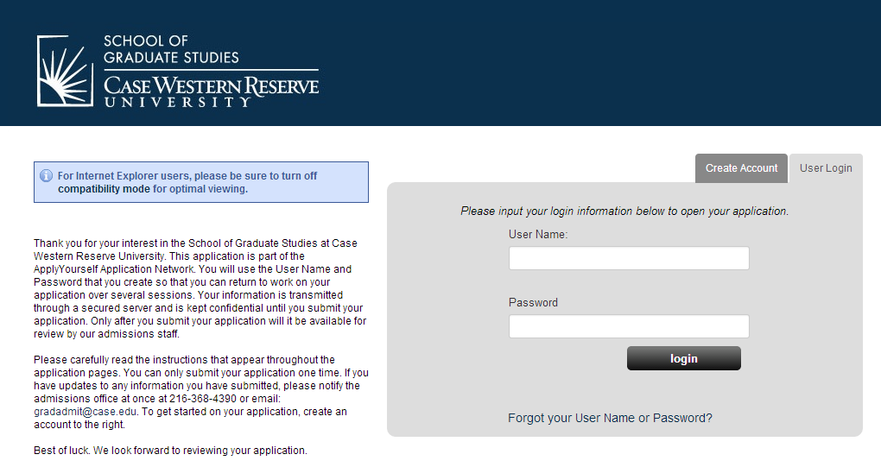
Figure 1

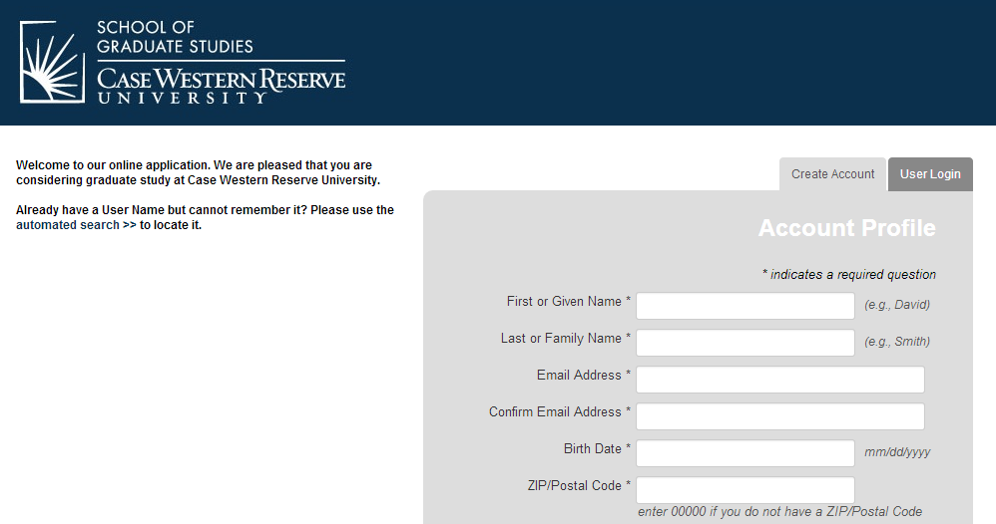

Figure 2

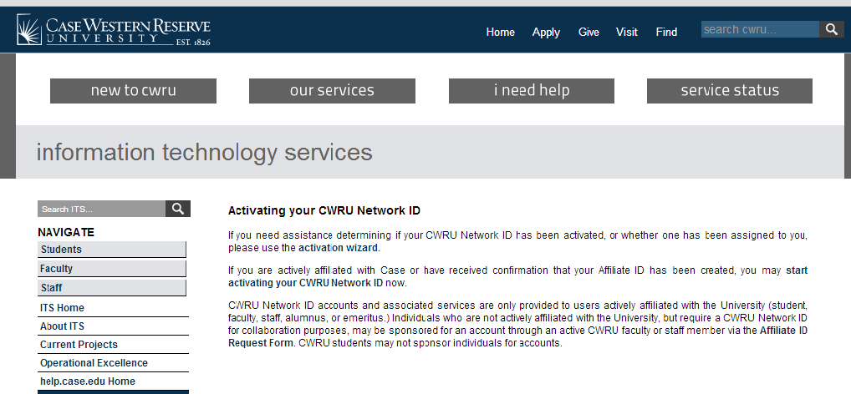
Figure 3

  - Once you have created an account, you will receive a message (Figure 4) stating an e-mail (Figure 5) has been sent confirming your new online application account for Case Western Reserve University, including the user name and password you will need for registration.

Figure 4

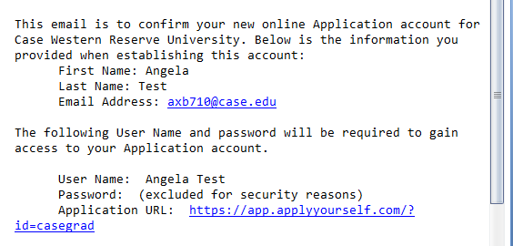

Figure 5

  - Having received your email, click on the ‘login’ button shown in Figure 4. The ‘Term of Use’ screen (Figure 6) will appear. Carefully read through the terms and conditions agreement. Then check both boxes, ‘I agree’ and ‘I have read the above notice’. Then click on ‘continue and create new account’.

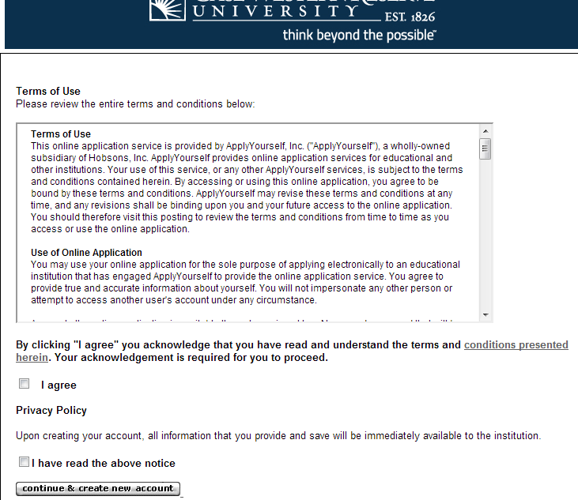

Figure 6

  - The ‘Welcome’ screen (figure 7) will appear. At this point, you may ‘START APPLICATION’ or review the ‘APPLICATION INSTRUCTIONS’. To begin the application, click on ‘START APPLICATION’. You may at any time save your progress and return at a later time. Should you save and exit the application, or your screen times out, you will need to log back in. The status of your application will be shown under ‘Application for Admission’ (Figure 8). In Figure 8, the submission status is ‘Not Submitted’. To continue your application click on ‘EDIT APPLICATION’.

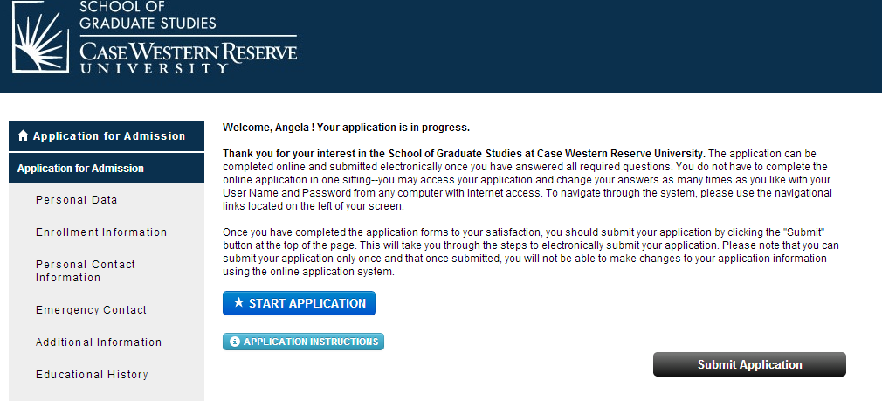

Figure 7

Figure 8

  - The first page, ‘Personal Data’ section (Figure 9), of the application appears. For the ‘Applicant type*’ select ‘Non-Degree’, and then complete the remainder of the information on this screen. Remember, at any time you may leave the application process and return at a later time. Just remember to save your data using the ‘Save’ option. Red asterisks fields are required. If any of these fields are left blank, you will either not be able to save and continue, or you will receive a message (Figure 10) at the end of the application process requesting that you complete the required field(s). Please complete as much of the application as possible as it makes the internal application process quicker and easier. Once you have completed this section, click the ‘Save & Continue’ box located both on the top and bottom of the page.
    - Note, on the left hand side, under ‘Application for Admission’, are the sections of the application. If you need to update a section, choose that section and make any necessary updates and then save those changes.

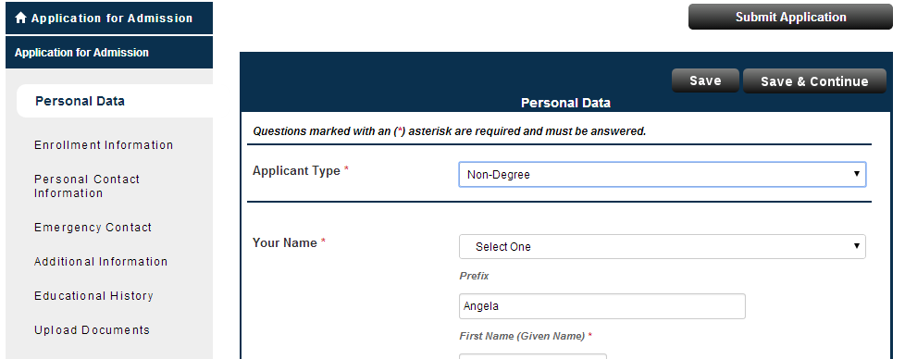

Figure 9

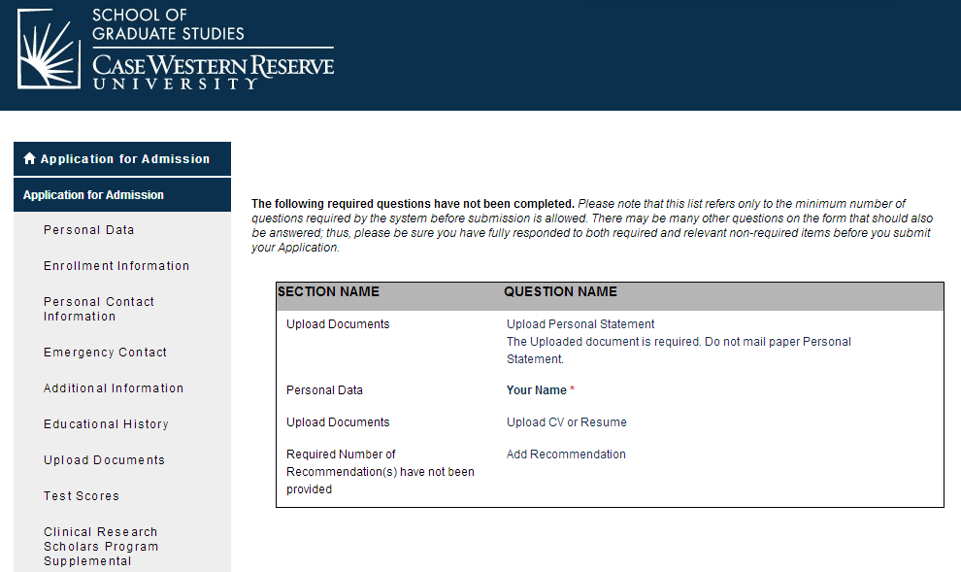

Figure 10

  - The ‘Non-degree Application Form’ screen (Figure 11) will appear. ‘Applicant Type*’ select ‘Non-Degree’. For CRSP 401, select ‘Summer 2016’ for the ‘Term*’. You will need your CWRU ID #. Remember, most University Hospital, VA, MetroHealth, and Cleveland Clinic employees already have one. Once you have completed this screen, click ‘save & continue’.

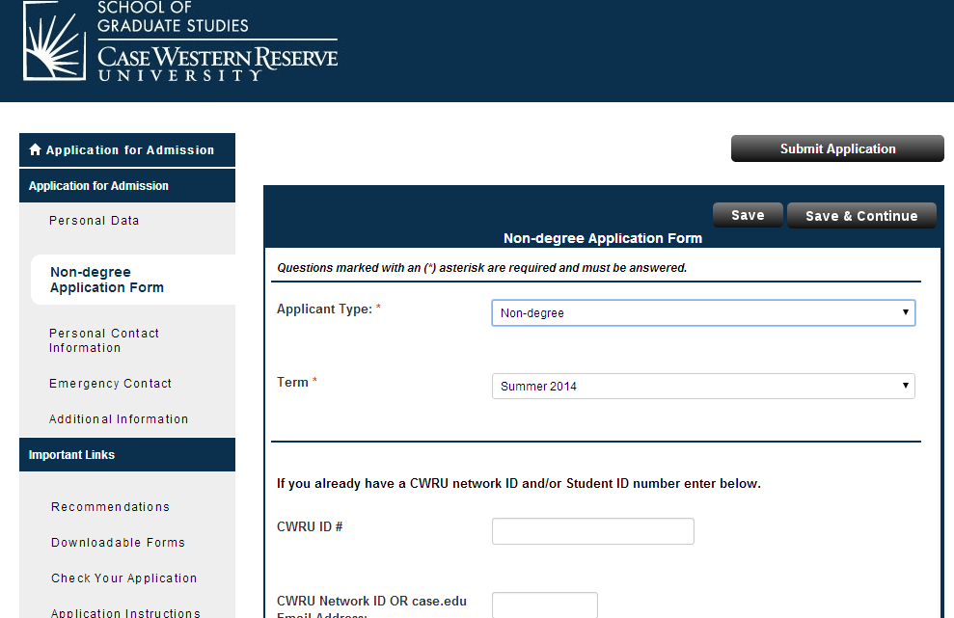
CRSP

Figure 11

  - The ‘Personal Contact Information’ screen (Figure 12) will appear. If you are an international student, under ‘Permanent Address‘, you must provide a foreign permanent address. The form will not be processed without this information. Complete this section and click ‘Save & Continue’.

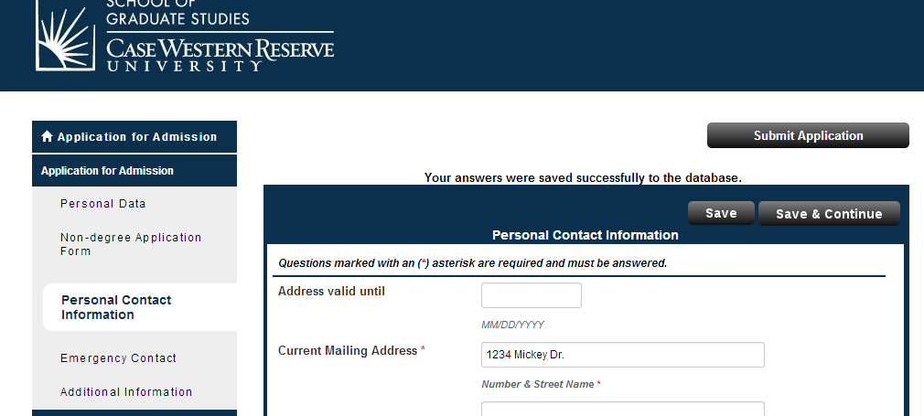

Figure 12

  - The ‘Emergency Contact’ screen (Figure 13) will appear. Again, complete this section, then click ‘save & continue’.

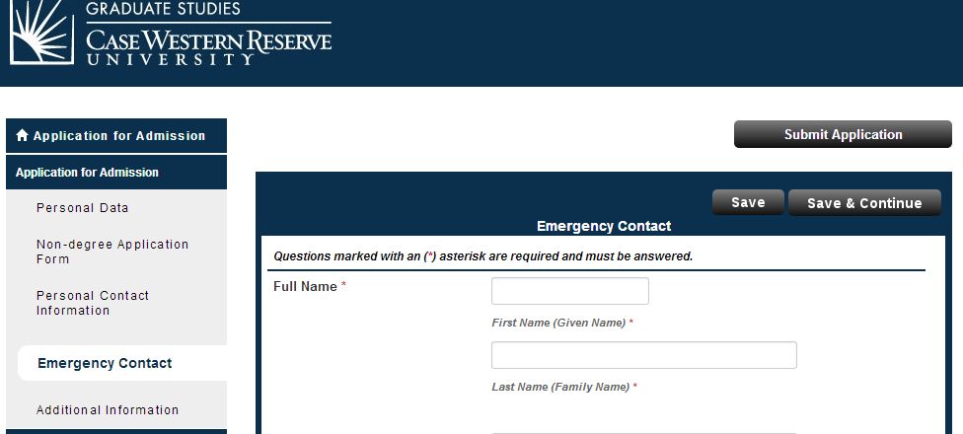

Figure 13

  - The next screen of the application is the ‘Additional Information’ screen (Figure 14). Complete and either ‘Save’ or ‘Save & Continue’.

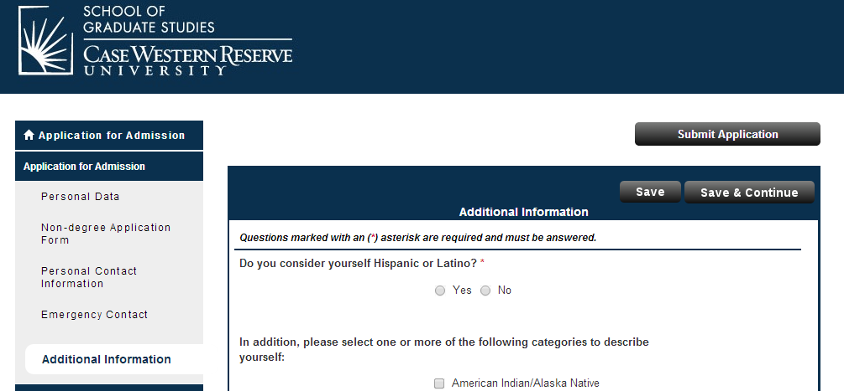

Figure 14

  - After saving the ‘Additional Information’, the ‘Educational History’ screen (Figure 15) will appear. Enter the requested information. If you do not know and Institution’s code, click on ‘Look up’ and the ‘LookUp’ screen (Figure 16) will appear. Once completed, click ‘Save’ or ‘Save & Continue’.

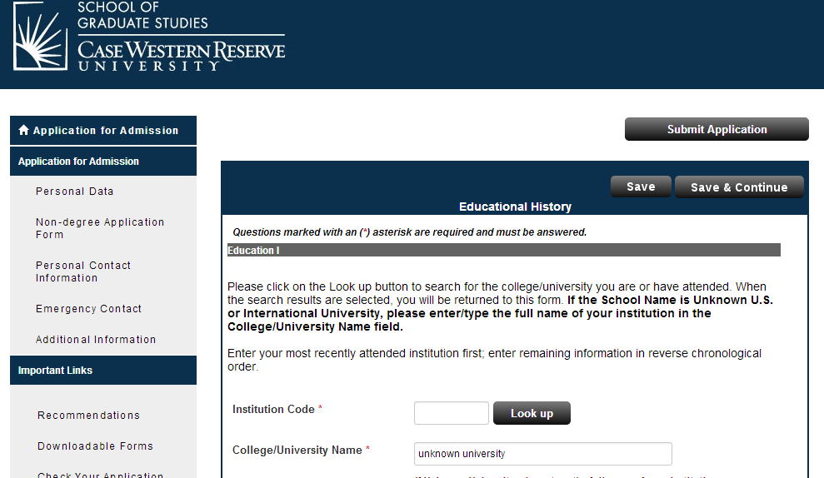

Figure 15

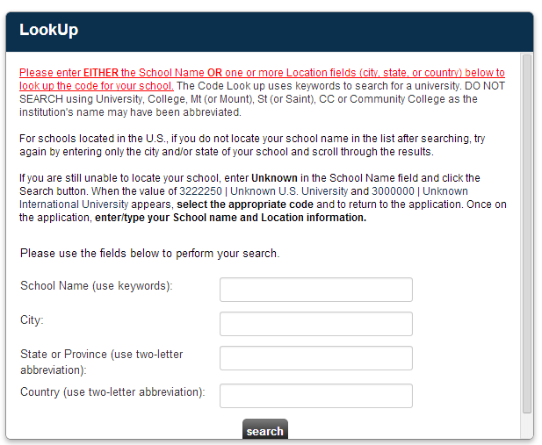

Figure 16

  - For additional information, check out the ‘Application instructions’ link listed under ‘IMPORTANT LINKS’. Click on ‘Non-Degree Seeking Students’ (Figure 17).
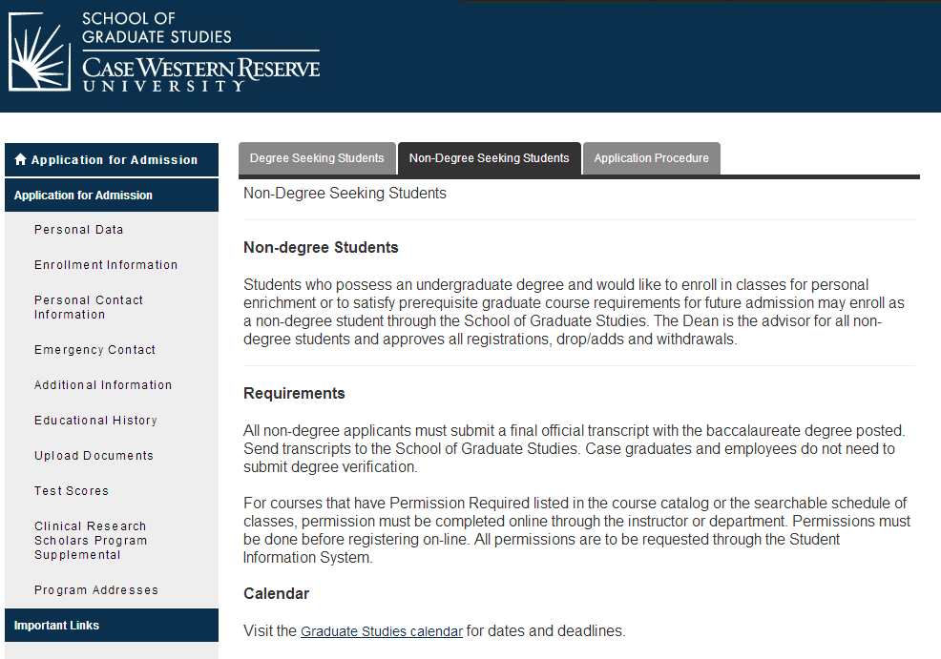

(Figure 17)

  - When you are ready to submit your application, click on ‘Submit Application’. The ‘Application Status: Ready for Submission’ screen (Figure 18) will appear. Please read the screen carefully. It is highly recommended that you review your application prior to final submission. Once you have reviewed your application, mark the box ‘I have read and …’ and click ‘continue’ on the bottom of this screen.

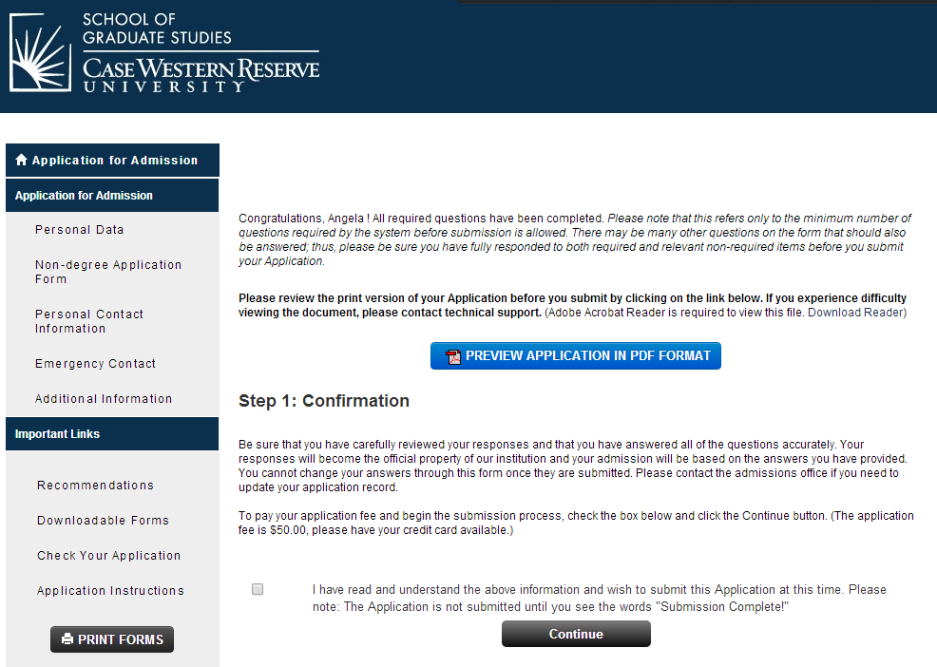
Figure 18

  - The ‘Application Fee Payment’ screen (Figure 19) will appear. Please read carefully and note that the application will not be processed without the $50 nonrefundable application fee. It is an administrative fee issued by the School of Graduate Studies. Click on ‘Credit Card’ in the ‘Select Payment Method’ area. Click ‘Pay and Continue’.

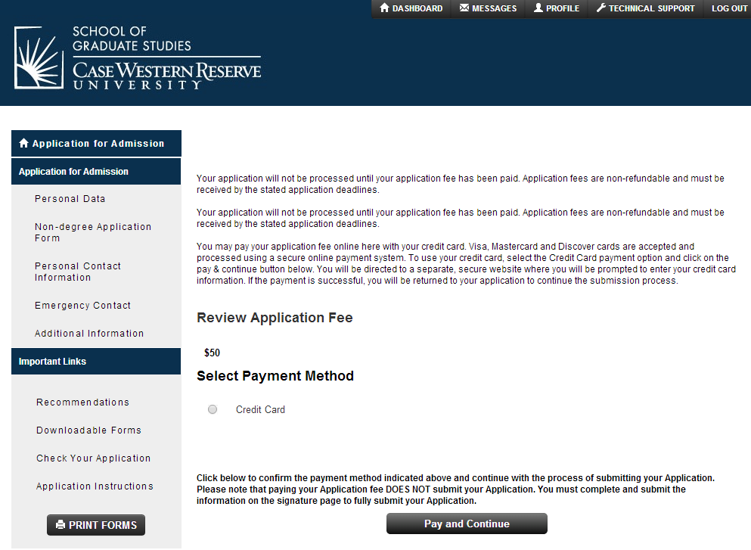
Figure 19
  - The credit card screen will appear, complete the information and submit.

  - Prior to submission, please print a hard copy of the application. Keep this copy for your records. For our records, please scan all pages of your application and e-mail it to the Center for Clinical Investigation at axb710@case.edu or fax it to 216-368-0207, attention Angela Bowling. Once completed, the application will be electronically delivered to the School for Graduate Studies.

  - The School of Graduate Studies will process these applications in batches, not every day. As the time for enrollment draws near they do try to attempt to process them daily. In order to give the School of Graduate Studies time to process your application, we ask that you submit your application as soon as possible.

  - The SIS system will not recognize you until the application is processed. Thus, you will need to wait until the application is processed before trying to enroll in the class. Once the application is processed, the School of Graduate Studies will issue you an acceptance letter/email (Figure 20). Click on the hyperlink, ‘Click here to accept or decline our offer of admission’ and complete the required steps. This action will create your SIS record and a ‘release/hold’ will be placed on your record. This ‘release/hold’ is automatically placed on all records. You will need to email Lynmarie Hamel, Associate Dean of Graduate Studies at lnmarie.hamel@case.edu, to process the ‘release/hold’. Once this process is completed, you will receive instructions for course registration via email from the School of Graduate Studies (also contained below).

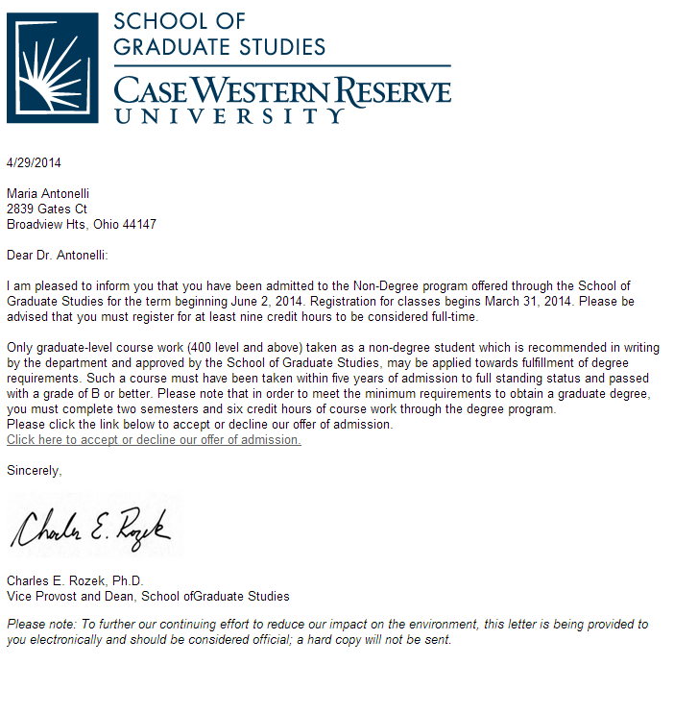

Figure 20

  - Once the ‘release/hold’ is processed, and an e-mail has been issued from the School of Graduate Studies you may enter SIS and register ().

The following are step-by-step guides on how to register for CRSP 401, Health Fee Waiver (fall and spring), Opting out of One-to-One-Fitness (fall and spring), and purchase a parking permit.

FOR SUMMER 2016 REGISTRATION, CRSP 401’S COURSE NUMBER IS 2494
How to Enroll in CRSP 401

- 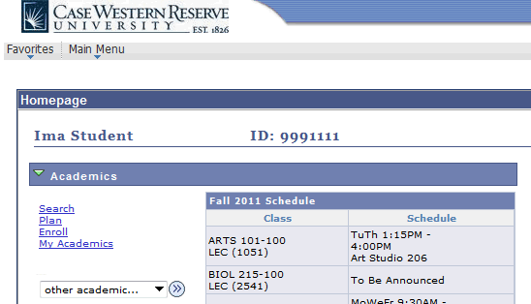Begin by logging in to the SIS at case.edu/sis with your CWRU Network ID and password.

2. | The Student Center appears.  Click the Enroll link.
3. | The Enroll tab appears.  If more than one term is open for enrollment or enrollment changes, you will be offered a choice of terms.  Click the radio button ( ) next to the appropriate term – Summer 2016.
4. | Click the Continue button.
5. | The Add Classes screen appears.  This screen contains the Shopping Cart, which will hold the classes selected from the schedule until you can enroll in them.  The Shopping Cart is open prior to and during registration, including before an individual's registration hold has been lifted.
6. | Add CRSP 401 to your Shopping Cart by using its Class Number (2494). Enter the  class number into the Enter Class Nbr field.
7. | Click the Enter button.
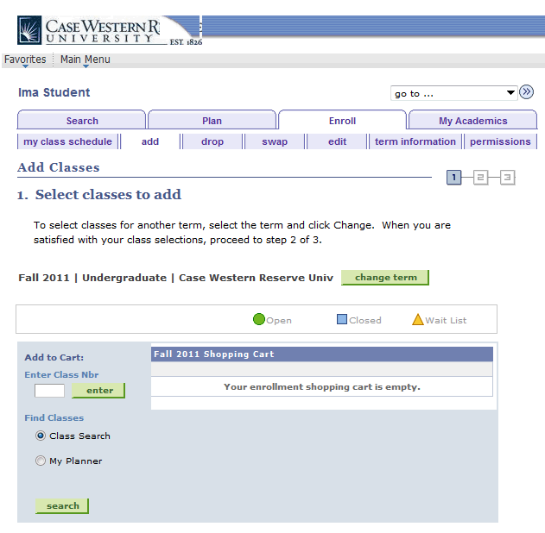
8. | The Enrollment Preferences screen appears.  Click the Next button to add the class to your Shopping Cart.
9. | A confirmation message appears and the class appears in your Shopping Cart.

If you make a mistake and want to remove the class from your Shopping Cart, click on the "trash can" icon to its left.

10. | To continue, click the Proceed to Step 2 of 3 button.
11. | The Confirm Classes screen appears. To continue registering, click the Finish Enrolling button.
12. | The View Results screen appears. Displayed next to each class is an indicator that tells you if you have been successfully enrolled in it.  A green checkmark means that you were successfully enrolled in the class.  A red X means that there is an error and the class cannot be added to your schedule. Read the message to determine why the class was not added.
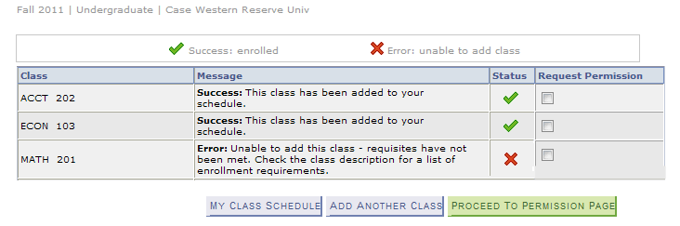
13. | To request permission to enroll in a class for which you received an error, select the class's Request Permission checkbox and click the Proceed to Permission Page button.  Classes that aren't successfully added to your schedule remain in your Shopping Cart.  Classes that are successfully added to your schedule are listed in the My Class Schedule section below the Shopping Cart  To get a printable page of your class schedule, click on the My Class Schedule button.

****PLEASE NOTE: FOR NON-CRF SCHOLARS – YOU DO NOT NEED TO WAIVE THE HEALTH FEE****

***PLEASE NOTE: For CRSP 401, or any other summer course you do not need to waive the healthcare fee. However, for fall and spring courses, you do need to waive the healthcare plan fee. The following is the step-by-step procedure to waive the health plan. ****
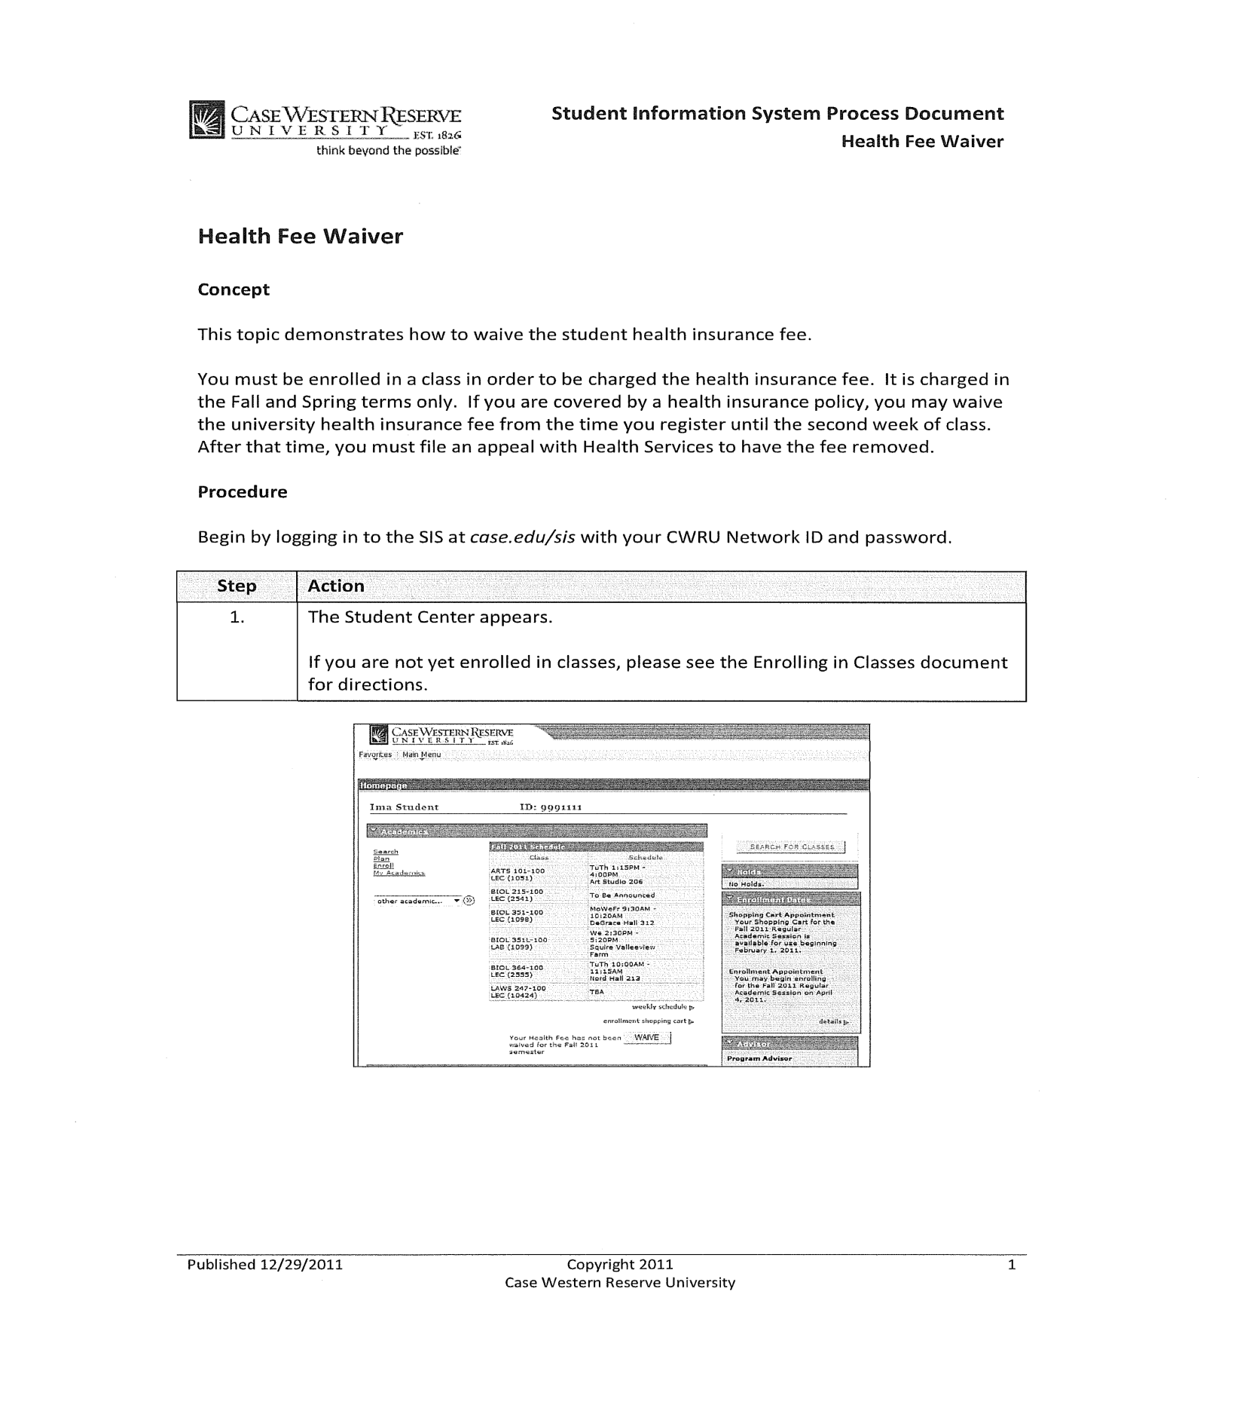

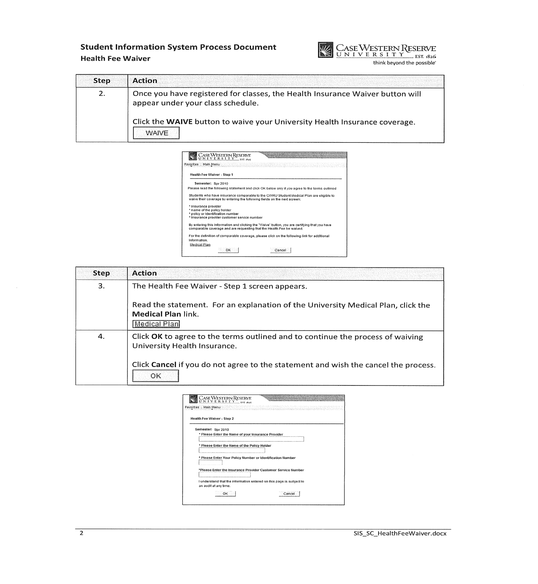

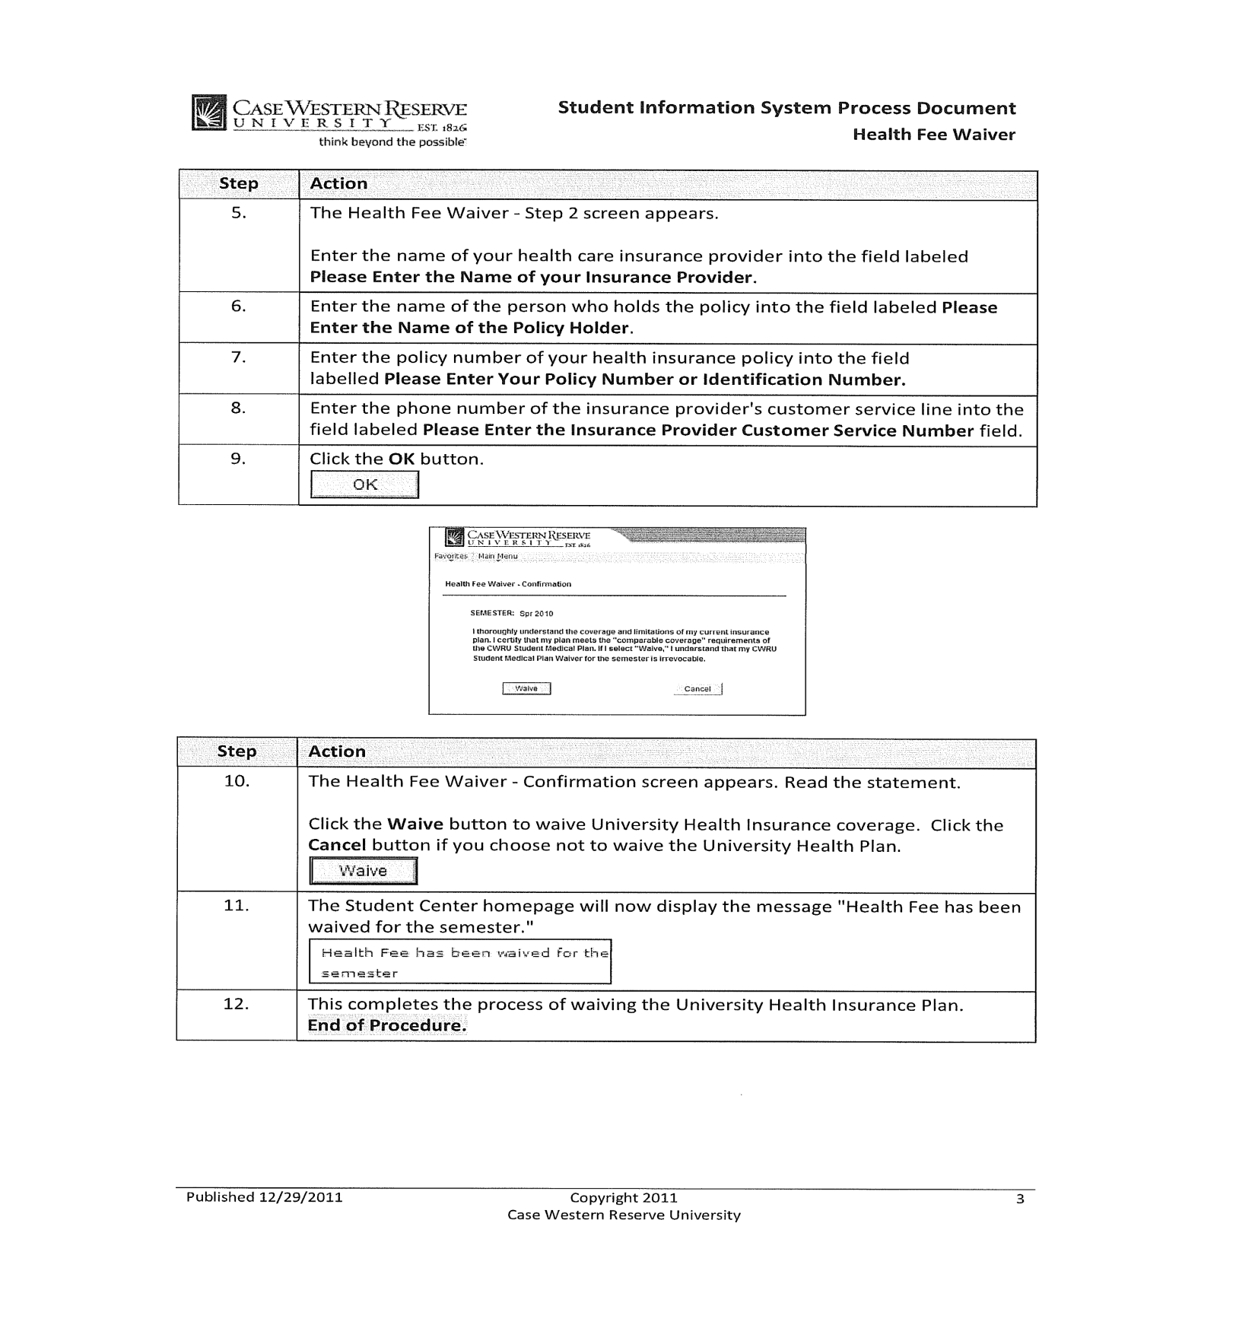

OPTING OUT OF ONE-TO-ONE FITNESS CHARGE

Starting Fall 2016 all graduate students will have an automatic One to One Fitness charge added to their student account. Fall 2016 fee is $145. If you do not want to use One to One Fitness you must opt-out (see instructions below) and you will not be charged the semester fee. Opting-out is semester specific and must be completed each semester for which you do not want to use One to One Fitness. If you do wish to take part in the discounted program and you intend to use your federal financial aid, you must grant permission for those funds to be used (as this is not normally a fee that is covered by aid unless specific permission is granted). Instructions to do that are below.

The last day to opt-out of One to One Fitness for Fall 2016 is September 9, 2016 (last day of drop/add).

If you have questions about the program, please contact Bryn Mota, Director of One to One Fitness, at bryn.mota@case.edu or 216-368-1121.

To opt-out of One to One Fitness:
At the end of the registration process, you will see an announcement of the One to One Membership fee below the Health Waiver button. Instructions to waive the One to One Membership Fee or keep the membership and use any Financial Aid funding in excess of your standard costs to cover the fee are outlined below.
You Can Waive the Fee From Two Places
1. If you are still on the Registration Results screen after you have registered:
· Select the “Click HERE to Waive the 1-2-1 Membership Fee”
· Click the WAIVE check box and then
· select “Save One to One Membership Fee.”
· You have successfully waived the One to One fee when you see “Optional Fee has been updated” with the WAIVE check box selected. You do not need to go any further.

2. If you forgot to waive it immediately after registering, you can do it from your Student Center Screen under Finances:
· Select the “Waive One to One Fee”
· Click the WAIVE check box and then
· select “Save One to One Membership Fee.”
· You have successfully waived the One to One fee when you see “Optional Fee has been updated” with the WAIVE check box selected. You do not need to go any further.

If you wish to KEEP the One to One Membership and wish to use federal aid:
1. If you are on the Registration Results screen after you have registered:
· Select “Click HERE to grant Financial Aid Permission to pay this fee
· Click the “Account Services” tab.
· Click the “Student Permission” tab. (If you have not allowed excess Financial Aid to pay for the One to One Membership fee, you will see a message stating “No student permission information on file”).
· Click the green “Grant Permissions” button.
· Read the agreement carefully and then select the green “Next” button.
· Read the final page carefully. If you agree, click the check box for “Yes, I have read the agreement”.
· Finally, click the green “Submit” button. You have successfully granted consent when you see “Your permission form has been accepted”.

2. If you did not give permission to use financial aid after you enrolled, you can do it from the Student Center Screen under Finances
· Click the “Account Inquiry” link in the Finances section
· Click the “Account Services” tab.
· Click the “Student Permission” tab. (If you have not allowed excess Financial Aid to pay for the One to One Membership fee, you will see a message stating “No student permission information on file”).
· Click the green “Grant Permissions” button.
· Read the agreement carefully and then select the green “Next” button.
· Read the final page carefully. If you agree, click the check box for “Yes, I have read the agreement”.
· Finally, click the green “Submit” button. You have successfully granted consent when you see “Your permission form has been accepted”.

If your tuition and fees are covered by your department or other sources, please contact them directly to find out if they will be covering this fee. If not, you will be responsible for it unless you waive it.

GENERAL PARKING INFORMATION

If you choose to park on campus you must purchase a hangtag parking permit and display it on the rearview mirror of your vehicle(s). All commuter students are eligible for permits upon enrollment.

- To obtain a parking permit:
- WHERE - Go to Crawford Hall (across from Severance Hall), Room 18 in the lower level. Office hours are Monday – Friday, 9:00 a.m. – 4:00 p.m.
- WHAT YOU WILL NEED - Bring Case ID, your license, and auto information (make, model, state vehicle is licensed, and license plate number). Please note that if you have a license from another country you are still eligible to get a permit.
- TYPE OF PERMITS – For summer you must determine the type of permit – part-time vs. full-time and weekly vs. monthly.
  - Part-time permits are issued to Master’s students taking less than 9 credit hours; whereas, full-time students are taking 9 credits or more during a semester. The difference being that part-time students must leave the assigned lot before 10:00 p.m., while, full time students do not have this restriction.
  - During the summer, permits may be purchased on a weekly or monthly basis. The schedule for the weekly permits is Monday through Friday. Monthly permits run on a calendar schedule and begin on the date you purchase the permit and ends 30 days later.
- RATES –
  - Rates are based on type of permit (weekly or monthly) and which lot you wish to park.
  - Rates for summer are determined in late April or early May and at that time can be found at http://www.case.edu/accessservices/parking_rates.html.
- LOTS –
  - For summer, permits are available for lots 5, 44, 47, 53, 29, 46, and 57 (see map).
  - Lots with gate arms require the use of a gate card or a university ID card for access. Case ID cards are automatically programmed upon permit issuance for access to the assigned lot.
  - If you need to park in an area other than your assigned area you may request a courtesy pass for closer parking from Education Support Services (ESS) at 216-368-5230, request Susan Sampson. The courtesy pass is a temporary permit in the lot that will best serve your needs for the duration of the disability.

- Things you need to know about the permit.
  - Your permit must be placed on your rearview mirror so it may be clearly viewed from the front of the vehicle.
  - If a hangtag is lost or misplaced, a replacement can be issued at Access Services, at a replacement fee.
  - Tampering with a hangtag may result in towing, a $100 fine, and loss of parking privileges.
  - Permits are transferable only to other vehicles owned by the permit holder or to rental cars.
  - Permit holders may not sell their hangtags to other individuals.
  - To update your new vehicle information, e-mail the new vehicle's license plate number, state of registration, year, make, model, and color of the vehicle) to access@case.edu.

Other questions or concerns?
- Contact access@case.edu

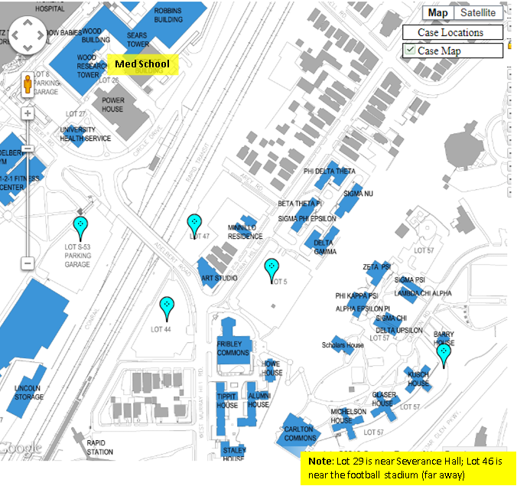

CRSP Courses
http://casemed.case.edu/CRSP/courses.cfm
View Course Descriptions for a complete list of courses and additional details.

REQUIRED (CORE) COURSES
Course # and Title | Credits | Semester offered
CRSP 401 - Introduction to Clinical Research | 3 | Summer
CRSP 402 - Study Design and Epidemiologic Methods | 3 | Fall
NURS 630 - Advanced Statistics: Linear Models | 3 | Fall
CRSP 413 - Communication in Clinical Research Seminar, Part 2 | 1 | Fall
CRSP 412 - Communication in Clinical Research Seminar, Part 1 | 1 | Spring
CRSP 603 - Research Ethics and Regulation | 2 | Fall
CRSP 651 - Thesis Research (9 credit hours are required) | 9 | Summer, Fall and Spring

RECOMMENDED COURSES
Course # and Title | Credits | Semester offered
CRSP 406 - Introduction to R Programming | 2 | Summer
CRSP 407 - Logistic Regression and Survival Analysis | 3 | Spring
CRSP 500 - Design & Analysis of Observational Studies | 3 | Spring

ELECTIVES
CRSP 410 - Independent Study in Clinical Research | 1-3 | Summer, Fall and Spring
CRSP 501 - Working in Interdisciplinary Research Teams | 1 | Fall
CRSP 502 - Leadership Development | 2 | Spring
CRSP 503 - Innovation and Entrepreneurship | 1 | Summer
CRSP 504 - Managing Research Records - A System's Approach | 2-3 | Spring
CRSP 505 - Investigating Social Determinants of Health | 2-3 | Spring
CRSP 510 - Health Disparities | 3 | Fall
EPBI 411 - Introduction to Health Behavior | 3 | Spring
EPBI 450 - Clinical Trials and Intervention Studies | 3 | Spring
EPBI 467 - Cost-Effectiveness Analysis in Health Care | 3 | Summer
*For the current course offerings/class schedules, please refer to the searchable "Schedule of Classes" at http://www.case.edu/provost/registrar/soc.html and enter "CRSP" in the appropriate field.

If you have any other questions, or concerns, please feel free to contact ccieducation@case.edu or 216-368-2601.

