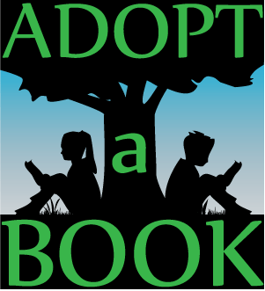
St. Rita School invites you to adopt a new book for our library. Donations will be accepted through December 15, 2017. Books can be purchased for $20 and will be plated with your special dedication. A new book will be chosen for you. Upon receipt of donation, a Christmas card of acknowledgement will be send to the person/family to who the book is being dedicated.

Dedication Options (to be placed on a bookplate)
- Merry Christmas to: ___________________________
- In Honor of: _________________________
- In Memory of: _________________________
- Other sentiment of your choosing:
Address of person whom book is being dedicated. (For acknowledgement purposes.)
_________________________________
_________________________________
_________________________________
Donated by: _________________________________
Address: ____________________________
____________________________
____________________________
The cost of each book is $20.00. Checks may be made out to St. Rita School. For inquiries or questions please contact Mrs. Schreck at sschreck.stritaschool@gmail.com.
Thank you for your generous support of the SRS School library!

