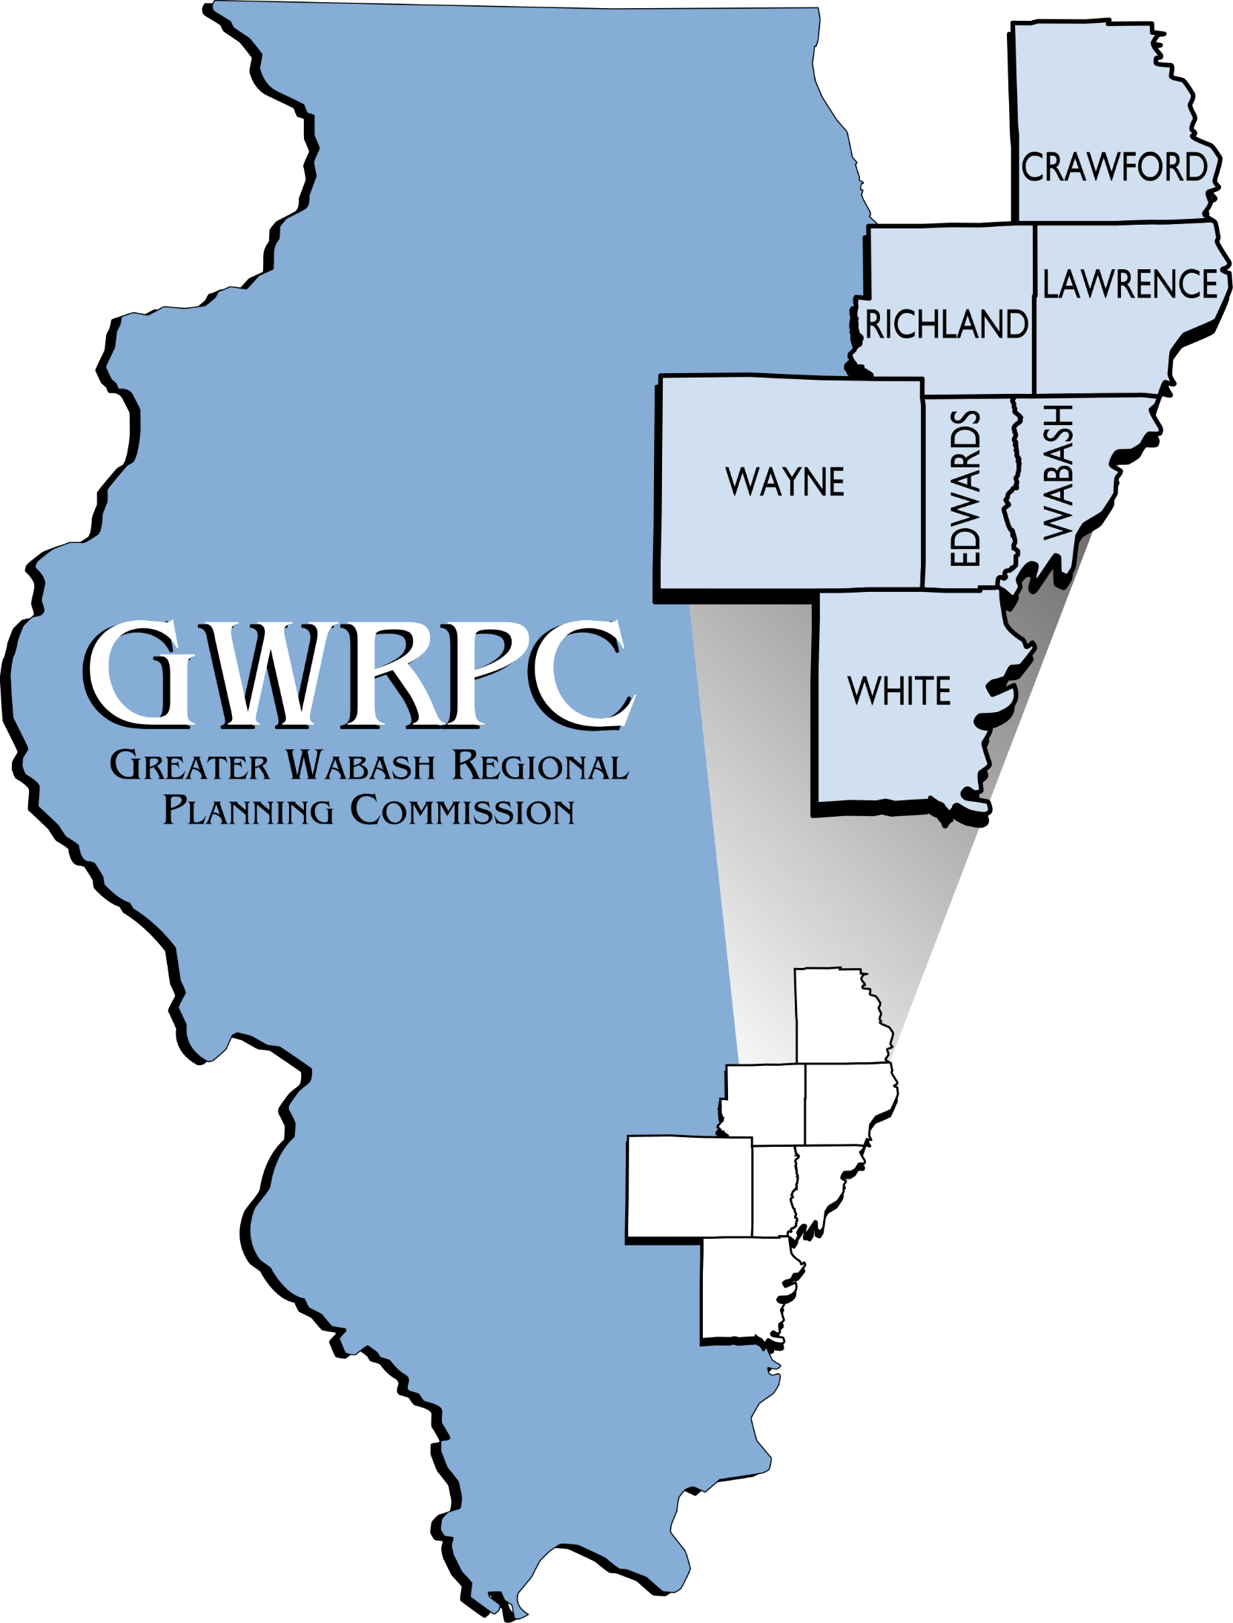
Greater Wabash Regional Planning Commission

UPCOMING GRANT DEADLINES
Department of Commerce and Economic Opportunity
Summer/Fall 2017- CDAP Public Facilities Construction- Local governments and rural water districts can apply for up to $450,000 for construction of water, sewer or storm sewer projects.

Summer/Fall 2017– CDAP Housing Rehabilitation Grants- Local government can apply for up to $400,000 to help provide safe and sanitary living conditions for low-to-moderate income residents. Grant funds are used to upgrade the existing housing stock in the community.

Open Grant- CDAP Economic Development- Local governments can apply for up to $750,000 in grant funds for infrastructure to assist a business in locating in an area that needs infrastructure. There is also a loan component in which businesses can apply for loan funds.

Open- Energy Now- Energy rebate grants for schools and governments served by Ameren Gas or Electric. For more information:
https://www.illinois.gov/dceo/whyillinois/TargetIndustries/Energy/Pages/PublicSectorStandardandCustomIncentivePrograms.aspx
Department of Natural Resources
Summer 2017- Illinois Department of Natural Resources OSLAD Grants– Open Space Land Acquisition and Development assists local government agencies in acquiring or developing public parks or open spaces. Funding assistance up to 50% of the project costs. Grant awards up to $750,000 for land acquisition and $400,000 for development projects. Examples of eligible projects include: picnic and playground facilities, outdoor nature facilities, sports courts and play fields, swimming pools and beaches, campgrounds and fishing piers, winter sports facilities, park roads and paths, parking and restrooms.

Also, see PDF on IL DNR grants.
USDA Rural Development

Open Grant- USDA/RD Community Facilities- Grant funds may be used to assist in the development of essential community facilities. Grant funds can be used to construct, enlarge, or improve community facilities for health care, public safety, and community and public services. This can include the purchase of equipment required for a facility's operation. Matching grant not to exceed $25,000.

TBA- USDA/RD RBDG- Rural Business Development Grant- provides grants for rural projects that finance and facilitate development of small and emerging rural businesses help fund business incubators, and help fund employment related adult education programs. There is no required maximum level of grant funding. However, smaller projects are given higher priority. Generally, grants range $10,000 up to $500,000.

TBA- Transportation Enhancement Program- ITEP provides funding for community based projects that expand travel choices and enhance the transportation experience by improving the cultural, historic, aesthetic and environmental aspects of our transportation infrastructure. Project sponsors may receive up to 80 percent reimbursement for eligible project costs. http://www.idot.illinois.gov/transportation-system/local-transportation-partners/county-engineers-and-local-public-agencies/funding-opportunities/ITEP.
Illinois Department of Transportation

Open Grant- IDOT Economic Development Program-The purpose of the Economic Development Program (EDP) is to provide state assistance in improving highway access to new or expanding industrial distribution or tourism developments. Generally, a 50/50 matching grant.

TBA- Safe Routes to School Projects - The Illinois Safe Routes To School (SRTS) Program supports projects and programs that enable and encourage walking and bicycling to and from a K-8 school.
FEMA- Federal Emergency Management Agency

TBA- FEMA/IEMA- Hazard Mitigation Grant Program- The Illinois Emergency Management Agency administers the HMGP and makes grants available to local governments as well as eligible private, non-profit organizations to implement cost-effective and long-term mitigation measures following a major disaster declaration. 75% federal grant funding. Only eligible for Counties with a PreDisaster Mitigation Plan.

TBA- FEMA- Assistance to Firefighters– Grant to help fire departments obtain critically needed equipment, protective gear, emergency vehicles, training and other resources needed to protect the public.

TBA- FEMA- SAFER- Staffing for Adequate Fire and Emergency Response
TBA- FEMA- Fire Prevention and Safety
TBA- FEMA- Fire Station Construction Grant
US Economic Development Administration

Open Grant- Economic Development Administration- grant funds available (50/50 match) that will promote comprehensive, entrepreneurial and innovation-based economic development efforts to enhance the competitiveness of regions, resulting in increased private investment and higher-skill, higher-wage jobs.
OTHER
May 31, 2017- Delta Regional Authority Grants- White County Only- DRA grants enhance the economic development activities in the Delta Region.

TBA- EPA Brownfields Grants (clean-up or assessment)

TBA- Live and Learn Library Grants- Apply for up to $35,000 mini-grant to remodel/expand existing or build new libraries. (Smaller grants available for ADA compliance).

TBA- COPS Hiring Program- CHP provides funding to hire and re-hire entry level career law enforcement officers in order to preserve jobs, increase community policing capacities and support crime prevention efforts. CHP grants may be used to (1) hire new officers or (2) re-hire officers already laid off by any jurisdictions or (3) rehire officers scheduled to be laid off. Funds 75% of the approved entry-level salaries and fringe benefits of each officer, up to $125,000 per office over a 3-year period.

