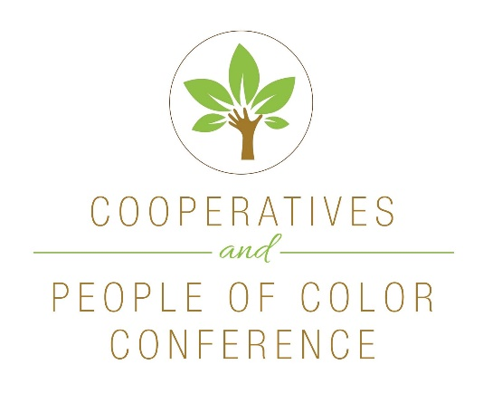
Friday, October 20, 2017
9:00 – 9:15 am Welcome and Introductions
Deb Trocha, Executive Director, ICDC
Imhotep Adisa, Executive Director, Kheprw Institute
Invocation

9:15 – 10:15 am Dr. Jessica Gordon Nembhard
Author of Collective Courage: A History of African American Cooperative Economic Thought and Practice
10:15 - 10:30 am Break
10:30 - 11:30 am Iya'falola H. Omobola
Founder and Co-Director, Cooperation Jackson

11:30 - 12:30 pm Lunch

12:30 - 1:30 pm Malik Yakini
Founder and the Executive Director, Detroit Black Community
Food Security Network (DBCFSN)

1:30 – 2:30 pm Sohnie Black, Community Organizer, Fund for Democratic
Communities (F4DC)

2:30 – 2:45 pm Break

2:45 – 3:45 pm Heiny Maldonado, Executive Director, Fuerza Laboral Raul Figueroa, Community Organizer, Fuerza Laboral
3:45 – 4:00 pm Wrap-up
Benediction

5:30 – 8:30 pm Reception
Kheprw Insitute, 3549 Boulevard Place

